






Perform clerical procedures
D1.HRS.CL1 11
D1.HOT.CL1.05
D2.TCC.CL1.09
Trainer Guide

Perform clerical procedures

D1.HRS.CL1 11
D1.HOT.CL1.05
D2.TCC.CL1.09

Trainer Guide




Project Base
William Angliss Institute of TAFE
555 La Trobe Street
Melbourne 3000 Victoria
Telephone: | (03) 9606 2111
Facsimile: | (03) 9670 1330
Acknowledgements
Project Director: | Wayne Crosbie
Chief Writer: | Alan Hickman
Subject Writer: | Birgitta March
Project Manager/Editor: | Alan Maguire
DTP/Production | Daniel Chee, Mai Vu, Jirayu Thangcharoensamut, Kaly Quach

The Association of Southeast Asian Nations (ASEAN) was established on 8 August 1967. The Member States of the Association are Brunei Darussalam, Cambodia, Indonesia, Lao PDR, Malaysia, Myanmar, Philippines, Singapore, Thailand and Viet Nam.
The ASEAN Secretariat is based in Jakarta, Indonesia.
General Information on ASEAN appears online at the ASEAN Website: www.asean.org.
All text is produced by William Angliss Institute of TAFE for the ASEAN Project on “Toolbox Development for Priority Tourism Labour Division”.
This publication is supported by the Australian Government’s aid program through the ASEAN-Australia Development Cooperation Program Phase II (AADCP II).
Copyright: Association of Southeast Asian Nations (ASEAN) 2012.
All rights reserved.
Disclaimer
Every effort has been made to ensure that this publication is free from errors or omissions. However, you should conduct your own enquiries and seek professional advice before relying on any fact, statement or matter contained in this book. The ASEAN Secretariat and William Angliss Institute of TAFE are not responsible for any injury, loss or damage as a result of material included or omitted from this course. Information in this module is current at the time of publication. Time of publication is indicated in the date stamp at the bottom of each page.
Some images appearing in this resource have been purchased from stock photography suppliers Shutterstock and iStockphoto and other third party copyright owners and as such are non-transferable and non-exclusive. Clip arts, font images and illustrations used are from the Microsoft Office Clip Art and Media Library. Some images have been provided by and are the property of William Angliss Institute.
Additional images have been sourced from Flickr and SXC and are used under Creative Commons licence: http://creativecommons.org/licenses/by/2.0/deed.en

File name: TG_Perform_clerical_procedurese_refined.docx





Table of contents
Competency Based Training (CBT) and assessment an introduction for trainers 1
Competency standard 11
Notes and PowerPoint slides 17
Recommended training equipment 85
Instructions for Trainers for using PowerPoint – Presenter View 87
Appendix – ASEAN acronyms 89

Competency Based Training (CBT) and assessment an introduction for trainers

Competency
Competency refers to the ability to perform particular tasks and duties to the standard of performance expected in the workplace.
Competency requires the application of specified knowledge, skills and attitudes relevant to effective participation, consistently over time and in the workplace environment.
The essential skills and knowledge are either identified separately or combined.
Knowledge identifies what a person needs to know to perform the work in an informed and effective manner.
Skills describe the application of knowledge to situations where understanding is converted into a workplace outcome.
Attitude describes the founding reasons behind the need for certain knowledge or why skills are performed in a specified manner.
Competency covers all aspects of workplace performance and involves:
- Performing individual tasks
- Managing a range of different tasks
- Responding to contingencies or breakdowns
- Dealing with the responsibilities of the workplace
- Working with others.

Unit of Competency
Like with any training qualification or program, a range of subject topics are identified that focus on the ability in a certain work area, responsibility or function.
Each manual focuses on a specific unit of competency that applies in the hospitality workplace.
In this manual a unit of competency is identified as a ‘unit’.
Each unit of competency identifies a discrete workplace requirement and includes:
- Knowledge and skills that underpin competency
- Language, literacy and numeracy
- Occupational safety and health requirements.
Each unit of competency must be adhered to in training and assessment to ensure consistency of outcomes.

Element of Competency
An element of competency describes the essential outcomes within a unit of competency.
The elements of competency are the basic building blocks of the unit of competency. They describe in terms of outcomes the significant functions and tasks that make up the competency.
In this manual elements of competency are identified as an ‘element’.

Performance criteria
Performance criteria indicate the standard of performance that is required to demonstrate achievement within an element of competency. The standards reflect identified industry skill needs.
Performance criteria will be made up of certain specified skills, knowledge and attitudes.

Learning
For the purpose of this manual learning incorporates two key activities:
- Training
- Assessment.
Both of these activities will be discussed in detail in this introduction.
Today training and assessment can be delivered in a variety of ways. It may be provided to participants:
- On-the-job – in the workplace
- Off-the-job – at an educational institution or dedicated training environment
- As a combination of these two options.
No longer is it necessary for learners to be absent from the workplace for long periods of time in order to obtain recognised and accredited qualifications.

Learning Approaches
This manual will identify two avenues to facilitate learning:
Competency Based Training (CBT)
This is the strategy of developing a participant’s competency.
Educational institutions utilise a range of training strategies to ensure that participants are able to gain the knowledge and skills required for successful:
- Completion of the training program or qualification
- Implementation in the workplace.
The strategies selected should be chosen based on suitability and the learning styles of participants.

Competency Based Assessment (CBA)
This is the strategy of assessing competency of a participant.
Educational institutions utilise a range of assessment strategies to ensure that participants are assessed in a manner that demonstrates validity, fairness, reliability, flexibility and fairness of assessment processes.

Flexibility in Learning
It is important to note that flexibility in training and assessment strategies is required to meet the needs of participants who may have learning difficulties. The strategies used will vary, taking into account the needs of individual participants with learning difficulties. However they will be applied in a manner which does not discriminate against the participant or the participant body as a whole.
Catering for Participant Diversity
Participants have diverse backgrounds, needs and interests. When planning training and assessment activities to cater for individual differences, trainers and assessors should:
- Consider individuals’ experiences, learning styles and interests
- Develop questions and activities that are aimed at different levels of ability
- Modify the expectations for some participants
- Provide opportunities for a variety of forms of participation, such as individual, pair and small group activities
- Assess participants based on individual progress and outcomes.
The diversity among participants also provides a good reason for building up a learning community in which participants support each other’s learning.
Participant Centred Learning
This involves taking into account structuring training and assessment that:
- Builds on strengths – Training environments need to demonstrate the many positive features of local participants (such as the attribution of academic success to effort, and the social nature of achievement motivation) and of their trainers (such as a strong emphasis on subject disciplines and moral responsibility). These strengths and uniqueness of local participants and trainers should be acknowledged and treasured
- Acknowledges prior knowledge and experience – The learning activities should be planned with participants’ prior knowledge and experience in mind
- Understands learning objectives – Each learning activity should have clear learning objectives and participants should be informed of them at the outset. Trainers should also be clear about the purpose of assignments and explain their significance to participants
- Teaches for understanding – The pedagogies chosen should aim at enabling participants to act and think flexibly with what they know
- Teaches for independent learning – Generic skills and reflection should be nurtured through learning activities in appropriate contexts of the curriculum. Participants should be encouraged to take responsibility for their own learning
- Enhances motivation – Learning is most effective when participants are motivated. Various strategies should be used to arouse the interest of participants
- Makes effective use of resources – A variety of teaching resources can be employed as tools for learning
- Maximises engagement – In conducting learning activities, it is important for the minds of participants to be actively engaged
- Aligns assessment with learning and teaching – Feedback and assessment should be an integral part of learning and teaching
- Caters for learner diversity – Trainers should be aware that participants have different characteristics and strengths and try to nurture these rather than impose a standard set of expectations.
Active Learning
The goal of nurturing independent learning in participants does not imply that they always have to work in isolation or solely in a classroom. On the contrary, the construction of knowledge in tourism and hospitality studies can often best be carried out in collaboration with others in the field. Sharing experiences, insights and views on issues of common concern, and working together to collect information through conducting investigative studies in the field (active learning) can contribute a lot to their eventual success.
Active learning has an important part to play in fostering a sense of community in the class. First, to operate successfully, a learning community requires an ethos of acceptance and a sense of trust among participants, and between them and their trainers. Trainers can help to foster acceptance and trust through encouragement and personal example, and by allowing participants to take risks as they explore and articulate their views, however immature these may appear to be. Participants also come to realise that their classmates (and their trainers) are partners in learning and solving.
Trainers can also encourage cooperative learning by designing appropriate group learning tasks, which include, for example, collecting background information, conducting small-scale surveys, or producing media presentations on certain issues and themes. Participants need to be reminded that, while they should work towards successful completion of the field tasks, developing positive peer relationships in the process is an important objective of all group work.

Competency Based Training (CBT)
Principle of Competency Based Training
Competency based training is aimed at developing the knowledge, skills and attitudes of participants, through a variety of training tools.
Training Strategies
The aims of this curriculum are to enable participants to:
- Undertake a variety of subject courses that are relevant to industry in the current environment
- Learn current industry skills, information and trends relevant to industry
- Learn through a range of practical and theoretical approaches
- Be able to identify, explore and solve issues in a productive manner
- Be able to become confident, equipped and flexible managers of the future
- Be ‘job ready’ and a valuable employee in the industry upon graduation of any qualification level.
To ensure participants are able to gain the knowledge and skills required to meet competency in each unit of competency in the qualification, a range of training delivery modes are used.
Types of Training
In choosing learning and teaching strategies, trainers should take into account the practical, complex and multi-disciplinary nature of the subject area, as well as their participant’s prior knowledge, learning styles and abilities.
Training outcomes can be attained by utilising one or more delivery methods:
Lecture/Tutorial
This is a common method of training involving transfer of information from the trainer to the participants. It is an effective approach to introduce new concepts or information to the learners and also to build upon the existing knowledge. The listener is expected to reflect on the subject and seek clarifications on the doubts.
Demonstration
Demonstration is a very effective training method that involves a trainer showing a participant how to perform a task or activity. Through a visual demonstration, trainers may also explain reasoning behind certain actions or provide supplementary information to help facilitate understanding.
Group Discussions
Brainstorming in which all the members in a group express their ideas, views and opinions on a given topic, is a free flow and exchange of knowledge among the participants and the trainer. The discussion is carried out by the group on the basis of their own experience, perceptions and values. This will facilitate acquiring new knowledge. When everybody is expected to participate in the group discussion, even the introverted persons will also get stimulated and try to articulate their feelings.
The ideas that emerge in the discussions should be noted down and presentations are to be made by the groups. Sometimes consensus needs to be arrived at on a given topic. Group discussions are to be held under the moderation of a leader guided by the trainer. Group discussion technique triggers thinking process, encourages interactions and enhances communication skills.
Role Play
This is a common and very effective method of bringing into the classroom real life situations, which may not otherwise be possible. Participants are made to enact a particular role so as to give a real feel of the roles they may be called upon to play. This enables participants to understand the behaviour of others as well as their own emotions and feelings. The instructor must brief the role players on what is expected of them. The role player may either be given a ready-made script, which they can memorise and enact, or they may be required to develop their own scripts around a given situation. This technique is extremely useful in understanding creative selling techniques and human relations. It can be entertaining and energising and it helps the reserved and less literate to express their feelings.

Simulation Games
When trainees need to become aware of something that they have not been conscious of, simulations can be a useful mechanism. Simulation games are a method based on "here and now" experience shared by all the participants. The games focus on the participation of the trainees and their willingness to share their ideas with others. A "near real life" situation is created providing an opportunity to which they apply themselves by adopting certain behaviour. They then experience the impact of their behaviour on the situation. It is carried out to generate responses and reactions based on the real feelings of the participants, which are subsequently analysed by the trainer.
While use of simulation games can result in very effective learning, it needs considerable trainer competence to analyse the situations.
Individual /Group Exercises
Exercises are often introduced to find out how much the participant has assimilated. This method involves imparting instructions to participants on a particular subject through use of written exercises. In the group exercises, the entire class is divided into small groups, and members are asked to collaborate to arrive at a consensus or solution to a problem.
Case Study
This is a training method that enables the trainer and the participant to experience a real life situation. It may be on account of events in the past or situations in the present, in which there may be one or more problems to be solved and decisions to be taken. The basic objective of a case study is to help participants diagnose, analyse and/or solve a particular problem and to make them internalise the critical inputs delivered in the training. Questions are generally given at the end of the case study to direct the participants and to stimulate their thinking towards possible solutions. Studies may be presented in written or verbal form.
Field Visit
This involves a carefully planned visit or tour to a place of learning or interest. The idea is to give first-hand knowledge by personal observation of field situations, and to relate theory with practice. The emphasis is on observing, exploring, asking questions and understanding. The trainer should remember to brief the participants about what they should observe and about the customs and norms that need to be respected.
Group Presentation
The participants are asked to work in groups and produce the results and findings of their group work to the members of another sub-group. By this method participants get a good picture of each other's views and perceptions on the topic and they are able to compare them with their own point of view. The pooling and sharing of findings enriches the discussion and learning process.
Practice Sessions
This method is of paramount importance for skills training. Participants are provided with an opportunity to practice in a controlled situation what they have learnt. It could be real life or through a make-believe situation.

Games
This is a group process and includes those methods that involve usually fun-based activity, aimed at conveying feelings and experiences, which are everyday in nature, and applying them within the game being played. A game has set rules and regulations, and may or may not include a competitive element. After the game is played, it is essential that the participants be debriefed and their lessons and experiences consolidated by the trainer.
Research
Trainers may require learners to undertake research activities, including online research, to gather information or further understanding about a specific subject area.

Competency Based Assessment (CBA)
Principle of Competency Based Assessment
Competency based assessment is aimed at compiling a list of evidence that shows that a person is competent in a particular unit of competency.
Competencies are gained through a multitude of ways including:
- Training and development programs
- Formal education
- Life experience
- Apprenticeships
- On-the-job experience
- Self-help programs.
All of these together contribute to job competence in a person. Ultimately, assessors and participants work together, through the ‘collection of evidence’ in determining overall competence.
This evidence can be collected:
- Using different formats
- Using different people
- Collected over a period of time.
The assessor, who is ideally someone with considerable experience in the area being assessed, reviews the evidence and verifies the person as being competent or not.
Flexibility in Assessment
Whilst allocated assessment tools have been identified for this subject, all attempts are made to determine competency and suitable alternate assessment tools may be used, according to the requirements of the participant.
The assessment needs to be equitable for all participants, taking into account their cultural and linguistic needs.
Competency must be proven regardless of:
- Language
- Delivery Method
- Assessment Method.
Assessment Objectives
The assessment tools used for subjects are designed to determine competency against the ‘elements of competency’ and their associated ‘performance criteria’.
The assessment tools are used to identify sufficient:
- Knowledge, including underpinning knowledge
- Skills
- Attitudes
Assessment tools are activities that trainees are required to undertake to prove participant competency in this subject.
All assessments must be completed satisfactorily for participants to obtain competence in this subject. There are no exceptions to this requirement, however, it is possible that in some cases several assessment items may be combined and assessed together.
Types of Assessment
Allocated Assessment Tools
There are a number of assessment tools that are used to determine competency in this subject:
- Work projects
- Written questions
- Oral questions
- Third Party Report
- Observation Checklist.
Instructions on how assessors should conduct these assessment methods are explained in the Assessment Manuals.
Alternative Assessment Tools
Whilst this subject has identified assessment tools, as indicated above, this does not restrict the assessor from using different assessment methods to measure the competency of a participant.
Evidence is simply proof that the assessor gathers to show participants can actually do what they are required to do.
Whilst there is a distinct requirement for participants to demonstrate competency, there are many and diverse sources of evidence available to the assessor.
Ongoing performance at work, as verified by a supervisor or physical evidence, can count towards assessment. Additionally, the assessor can talk to customers or work colleagues to gather evidence about performance.
A range of assessment methods to assess competency include:
- Practical demonstrations
- Practical demonstrations in simulated work conditions
- Problem solving
- Portfolios of evidence
- Critical incident reports
- Journals
- Oral presentations
- Interviews
- Videos
- Visuals: slides, audio tapes
- Case studies
- Log books
- Projects
- Role plays
- Group projects
- Group discussions
- Examinations.
Recognition of Prior Learning
Recognition of Prior Learning is the process that gives current industry professionals who do not have a formal qualification, the opportunity to benchmark their extensive skills and experience against the standards set out in each unit of competency/subject.
Also known as a Skills Recognition Audit (SRA), this process is a learning and assessment pathway which encompasses:
- Recognition of Current Competencies (RCC)
- Skills auditing
- Gap analysis and training
- Credit transfer.
Assessing competency
As mentioned, assessment is the process of identifying a participant’s current knowledge, skills and attitudes sets against all elements of competency within a unit of competency. Traditionally in education, grades or marks were given to participants, dependent on how many questions the participant successfully answered in an assessment tool.
Competency based assessment does not award grades, but simply identifies if the participant has the knowledge, skills and attitudes to undertake the required task to the specified standard.
Therefore, when assessing competency, an assessor has two possible results that can be awarded:
- Pass Competent (PC)
- Not Yet Competent (NYC).
Pass Competent (PC)
If the participant is able to successfully answer or demonstrate what is required, to the expected standards of the performance criteria, they will be deemed as ‘Pass Competent’ (PC).
The assessor will award a ‘Pass Competent’ (PC) if they feel the participant has the necessary knowledge, skills and attitudes in all assessment tasks for a unit.
Not Yet Competent’ (NYC)
If the participant is unable to answer or demonstrate competency to the desired standard, they will be deemed to be ‘Not Yet Competent’ (NYC).
This does not mean the participant will need to complete all the assessment tasks again. The focus will be on the specific assessment tasks that were not performed to the expected standards.
The participant may be required to:
a) Undertake further training or instruction
b) Undertake the assessment task again until they are deemed to be ‘Pass Competent’.

Competency standard
UNIT TITLE: PERFORM CLERICAL PROCEDURES |  |  |  | NOMINAL HOURS: 15 hours
UNIT NUMBER: D1.HRS.CL1 11, D1.HOT.CL1.05, D2.TCC.CL1.09
UNIT DESCRIPTOR: This unit deals with the skills and knowledge required to perform clerical procedures in a range of settings within the six labour divisions of the hotel and travel industries.
ELEMENTS AND PERFORMANCE CRITERIA | UNIT VARIABLE AND ASSESSMENT GUIDE
Element 1: Process office documents  - Process documents with appropriate office equipment in accordance with enterprise procedures and within designated timelines  - Identify and rectify and/or report malfunctions promptly in accordance with enterprise procedures  - Use office equipment to process documents  Element 2: Draft correspondence  - Write text using clear and concise language  - Ensure text is without spelling, punctuation and/or grammatical errors  - Check information for accuracy prior to sending  Element 3: Maintain document systems  - File/store documents in accordance with enterprise procedures  - Modify and/or update records management systems in accordance with enterprise procedures | Unit Variables  The Unit Variables provide advice to interpret the scope and context of this unit of competence, allowing for differences between enterprises and workplaces. It relates to the unit as a whole and facilitates holistic assessment  This unit applies to performing clerical procedures in a range of settings within the labour divisions of the hotel and travel industries and may include:  - Front Office  - Housekeeping  - Food and Beverage Service  - Food Production  - Travel Agencies  - Tour Operation.  Documents may include:  - Mail, such as incoming and outgoing correspondence, guest mail and courier  - Files, such as customer records, correspondence, financial records, receipts, invoices and orders  - Correspondence, such as letters, facsimiles, memos and reports  - Menus.  Process refers to:  - Collating  - Binding  - Photocopying  - Mailing  - E-mailing  - Filing.  Office equipment may include:  - Photocopier  - Facsimile  - Computer  - Printer  - Scanner.  Assessment Guide  The following skills and knowledge must be assessed as part of this unit:  - The enterprise’s policies and procedures in regard to processing office documents  - The enterprise’s policies and procedures in regard to using the filing system  - Demonstrated ability to draft correspondence, process documentation and maintain document systems.  Linkages to other units  This is a core unit that underpins effective performance in all other units. Combined training and assessment may be appropriate.  Critical Aspects of Assessment  Evidence of the following is essential:  - Demonstration of the ability to accurately process a range of office documentation within enterprise acceptable timeframes  - Demonstration of the ability to produce documents that are easily understood and error free.  Context of Assessment  - This unit may be assessed on or off the job  - Assessment should include practical demonstration either in the workplace or through a simulation, supported by a range of methods to assess underpinning knowledge  - Assessment must relate to the individual’s work area or area of responsibility  - Demonstration of skills across an operating period to address an adequate range of clerical procedures/tasks  - Performance of clerical procedures within typical workplace time constraints.
Resource Implications
Training and assessment to include access to a real or simulated office environment; and access to industry-current equipment.
Assessment Methods
The following methods may be used to assess competency for this unit:
- Observation of candidate performance
- Oral and written questions
- Practical exercises/case studies.
Key Competencies in this Unit
Level 1 = competence to undertake tasks effectively
Level 2 = competence to manage tasks
Level 3 = competence to use concepts for evaluating and reshaping tasks
 | Key Competencies | Level | Examples
 | Collecting, organizing and analysing information | 1 | Identify what information to include in  written correspondence
 | Communicating ideas and information | 1 | Produce written correspondence
 | Planning and organizing activities | 1 | Plan content and layout of written  correspondence; file documentation
 | Working with others and in teams | 1 | Produce written documentation for  Others
 | Using mathematical ideas and techniques | -
 | Solving problems | 1 | Resolve equipment malfunctions
 | Using technology | 1 | Use routine software to produce routine  office documents

Notes and PowerPoint slides
Slide
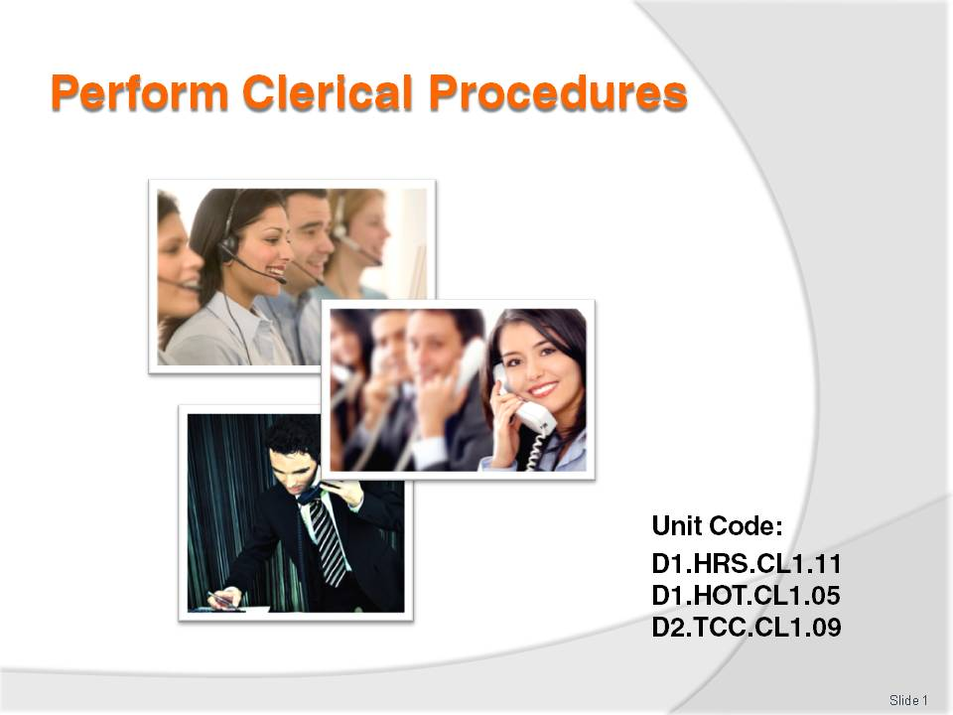
Slide No | Trainer Notes
 | Trainer to introduce purpose and content of unit.

Slide
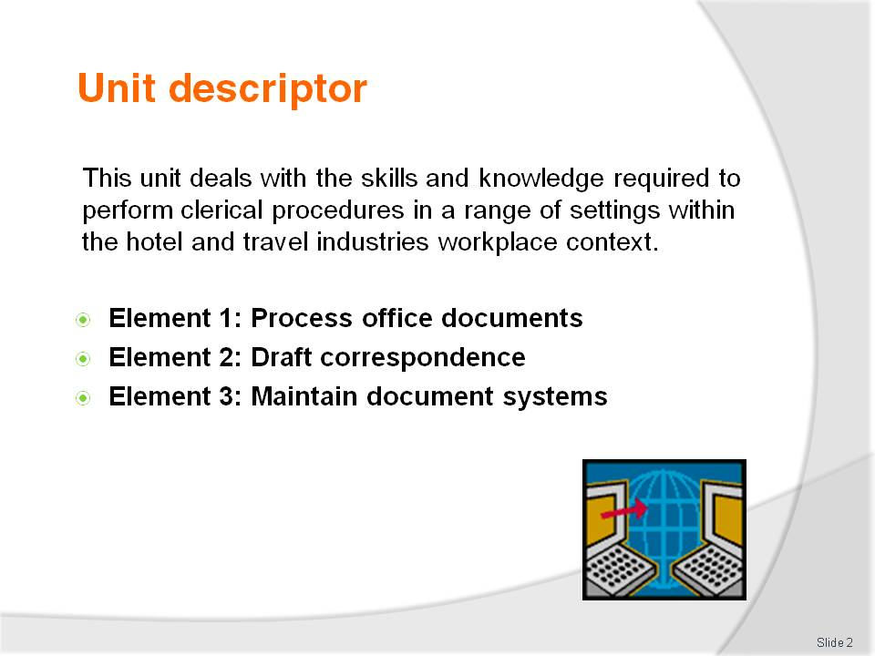
Slide No | Trainer Notes
Class room requirements: this unit can be only be delivered in:
- A computer room
- With an interactive whiteboard or data projector.

Slide
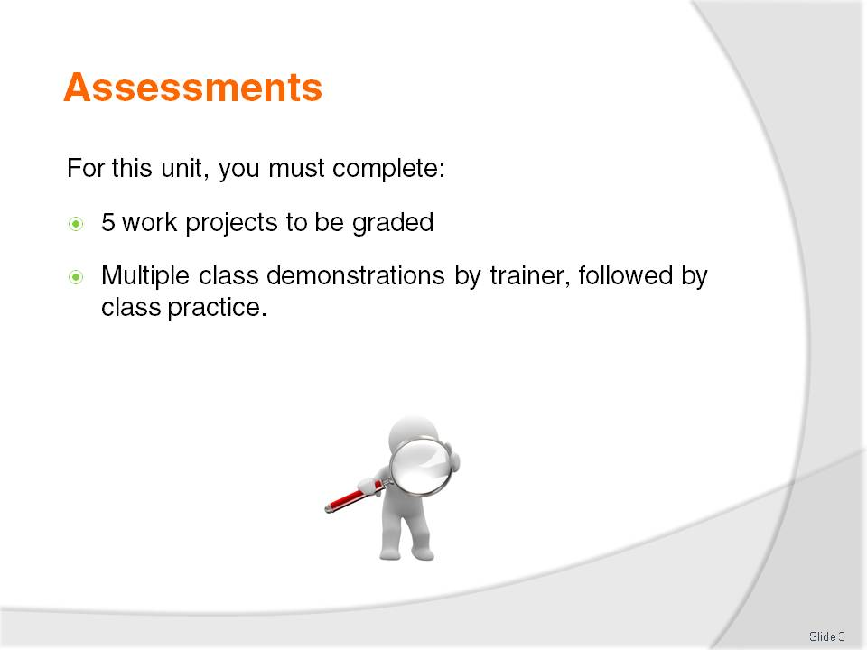
Slide No | Trainer Notes
 | Explain to trainees the 5 work projects are due by a date agreed to by you, the trainer, and graded.

Slide
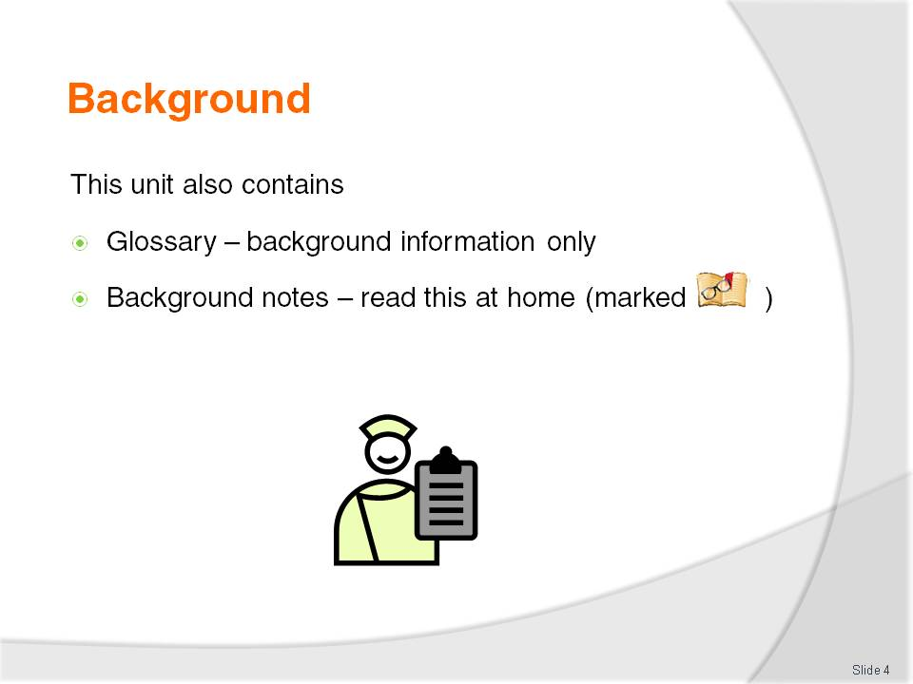
Slide No | Trainer Notes
Trainer to hand out TM.
Trainer to show glossary and background notes in Trainee Manual.

Slide
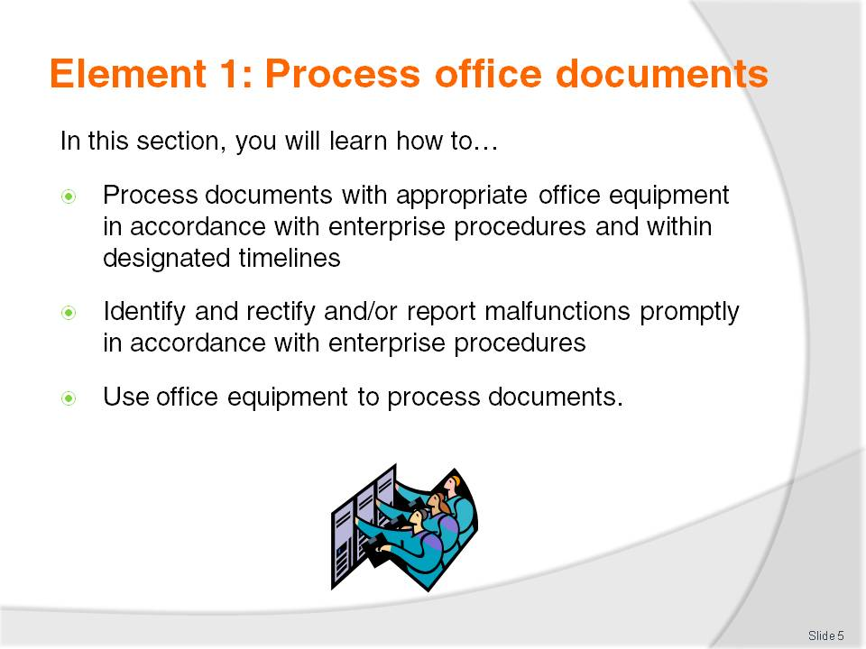
Slide No | Trainer Notes
 | Ask trainees: Who has relevant work experience in terms of use of use of office equipment, writing correspondence, filing, etc.?

Slide
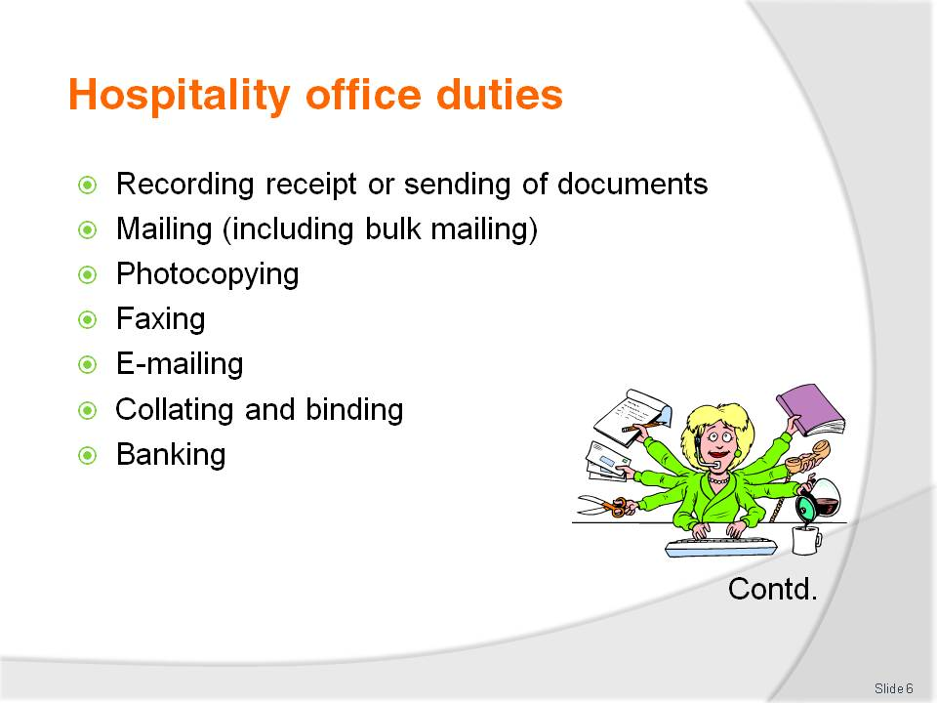
Slide No | Trainer Notes
 | Discuss office duties. Can you think of any more not listed here?

Slide
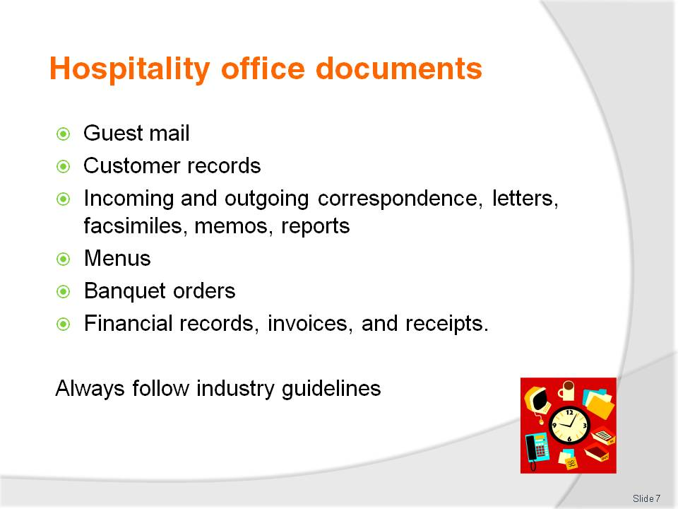
Slide No | Trainer Notes
- Ask trainees for their experience in industry guidelines in their workplace
- Link it to your own
- Bring in some samples
- Ask students to bring in non-sensitive correspondence or office documentation to show consistency across the board.

Slide
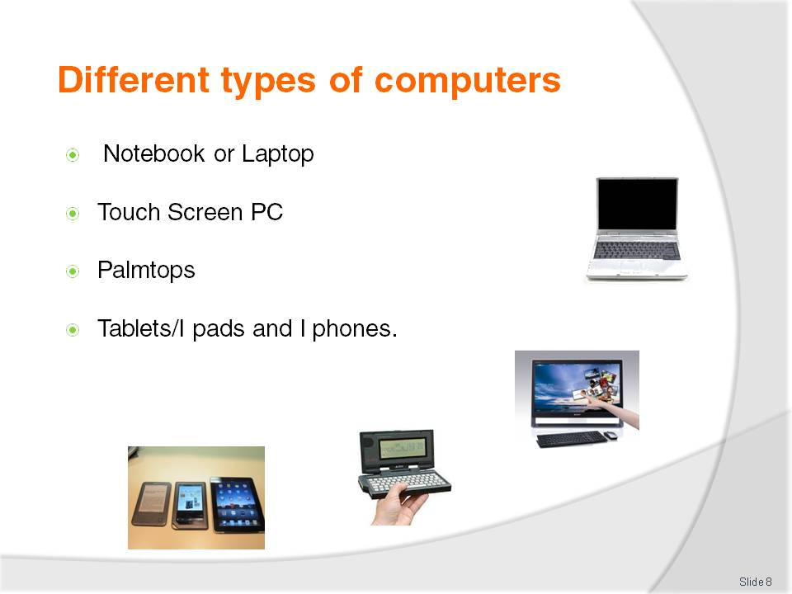
Slide No |  | Trainer Notes
Trainer to explain types of computers and his/her own experience.
Notebook or Laptop
These are portable computers which are used by people “on the go”. A notebook is similar in size to a standard book. A laptop is larger than a notebook. They are both lightweight, very convenient but are not as fast as a fixed PC, have a shorter battery life and can easily be damaged if not taken care of.
Touch Screen PC
This is a PC that can be held in the hand. A touch screen looks similar to a notebook/laptop monitor, though they can vary in style. A special pen is used to access different menu options on the touch screen. There is no keyboard or mouse.
Palmtops
Mini computers are designed to perform basic computer functions and fit in the palm of the hand. Many are used in conjunction with a normal PC. There are different styles available. Two common types are shown. You can transfer data from your PC to the Palmtop as reference or to edit on the go. The palmtop is not as powerful as a PC. Palmtops can be connected to the internet, or to a PC and are useful when travelling to send and receive email.
Tablets/I pads and I phones
IPads and android tablets are a combination of a modern smart phone and a laptop computer. Business owners often use tablets to get tasks done on the run, create presentations for meetings and update websites and blogs. They are lightweight, compact and affordable. They can easily be synchronised with your computer when returning to the office.
Slide
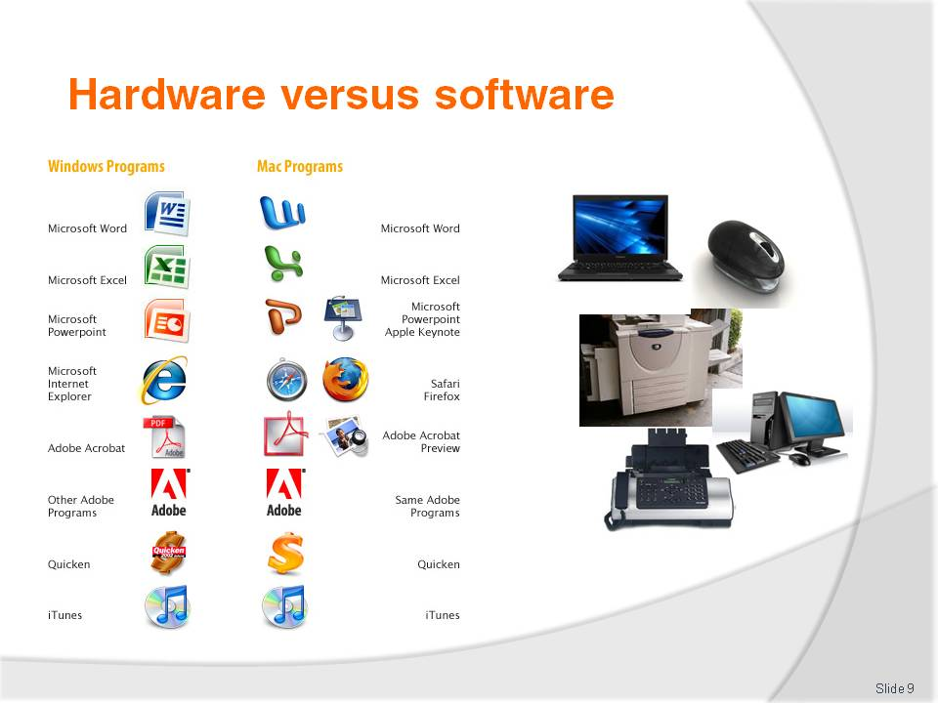
Slide No | Trainer Notes
Trainer to explain:
Hardware
The physical components of a computer system - everything that you can touch - are called hardware.
Software
The programs used on a computer are called software. This includes system software (such as Windows, Mac OS etc.) and application software such as Microsoft Word, Microsoft Excel, etc. System software is necessary in order to run a computer and all applications within it.

Slide
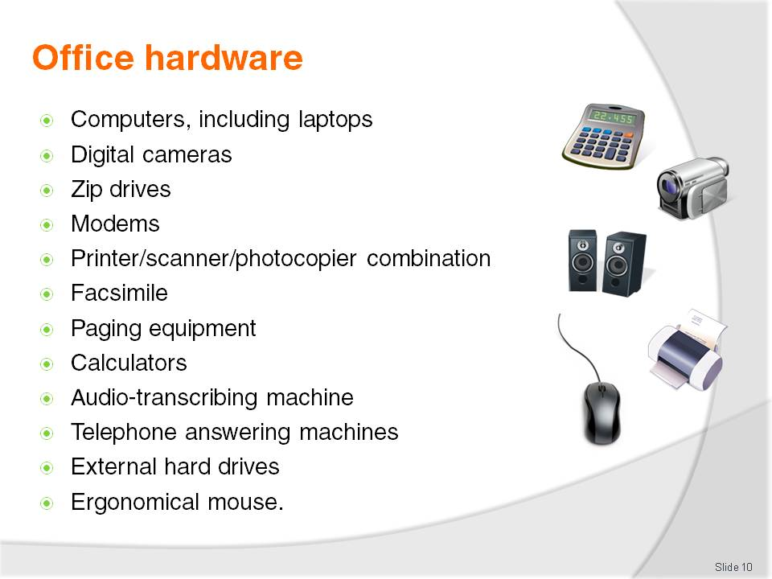
Slide No | Trainer Notes
Discuss office hardware:
Can you think of any more not listed here?

Slide
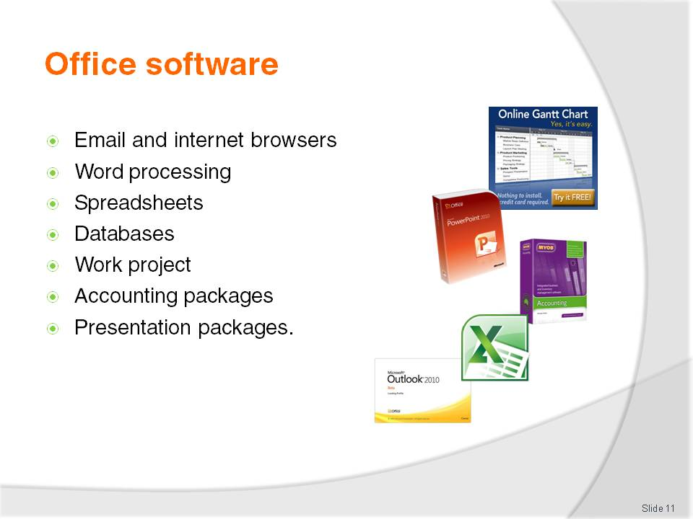
Slide No | Trainer Notes
- Trainer to explain the internet browsers available in their country (e.g. Internet Explorer, Mozilla Firefox) and ask what trainees use at work and at home
- Trainer to ask what software trainees use to do word processing: Word for Windows? Or do they use Apple Mac and download Word onto it? Trainer to explain there are different versions of Word e.g. 2003, 2007, 2010
- Trainer to ask what spreadsheets trainees use (eg Excel) and what they feel is good/not as good about it. Do they know how to sort it? Enter formulas?
- Trainer to explain that engineers, for example, use a project management tool called Microsoft Project which allows them to track projects
- Trainer to explain that there are various packages to do accounting/bookkeeping such as MYOB, Quicken
- Trainer to explain that he/she uses Power Point – trainer to explain its advantages for presentations.

Slide
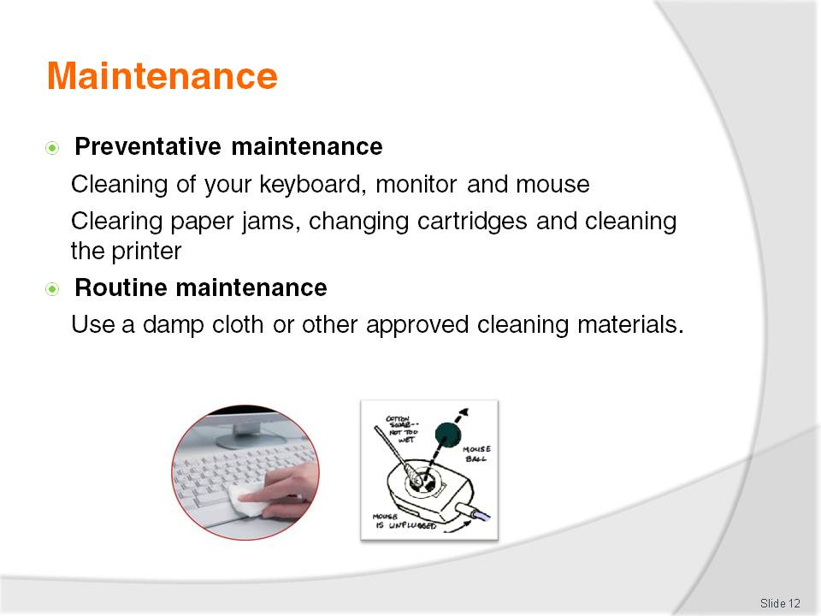
Slide No | Trainer Notes
- Explain how this works and link it to your own experience e.g. When I am at the workplace, the procedure for routine maintenance is…. Or the procedure for ordering Consumables is…..
- Demonstrate how to do it: turn the keyboard upside down and gently tap the bottom of the keyboard. Show trainees how to clean monitors with a damp cloth. Demonstrate how you open the mouse, remove the panel, and clean the tracking ball and the rollers inside the mouse
- Ask trainees what their workplace experience is in relation to ordering new consumables and organising maintenance? Do they have to use a log? Did they get training on how to deal with this?

Slide
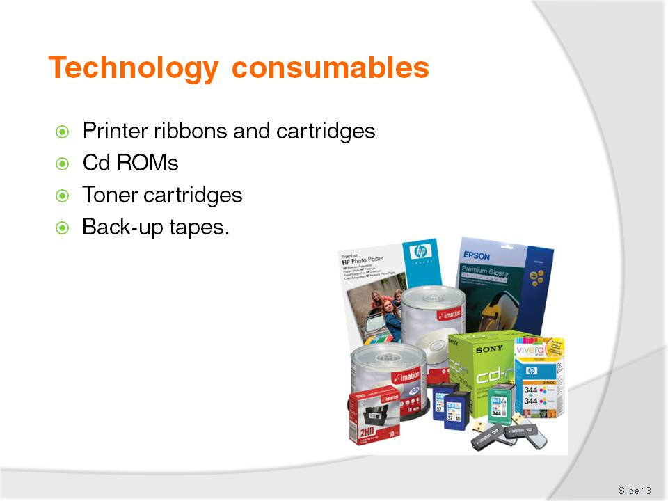
Slide No | Trainer Notes
 | Trainer to bring in some consumables such as per picture.

Slide
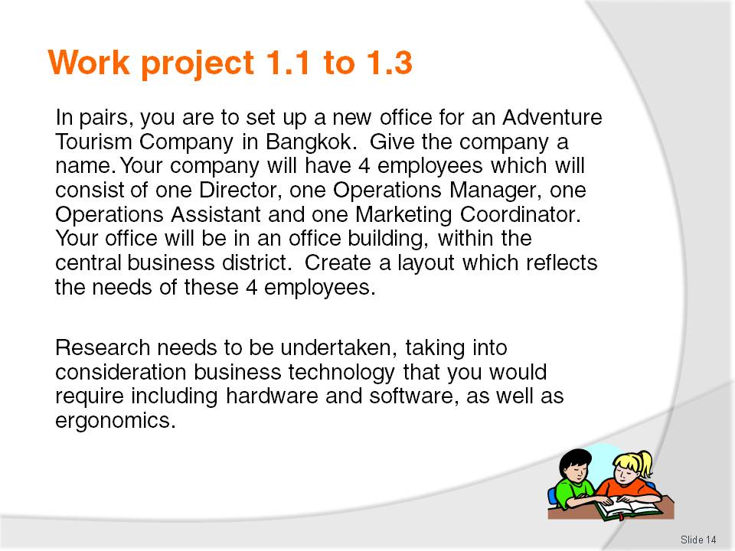
Slide No | Trainer Notes
Trainer is to read the work project to trainees. Explain there are two separate parts: one written, one oral presentation in pairs. Set a due date for this project to be handed in, mark and return the projects to trainees
This is project 1 of 5.

Slide
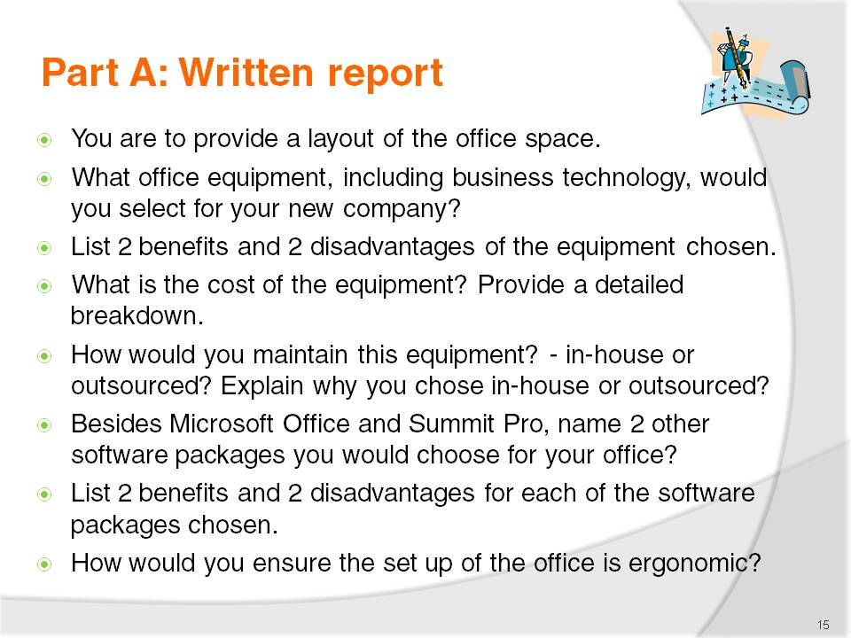
Slide No | Trainer Notes
 | Trainer to explain the report requirements to trainees and assist them to find resources to help them answer the questions. Trainer may give the trainees the option of working individually, in pairs or in groups.

Slide

Slide No | Trainer Notes
Show trainees attached sample assessment:
- Set standard of your expectations
- Set due date for part A
- Set due date for part B
- Consider weight of this assessment.

Slide
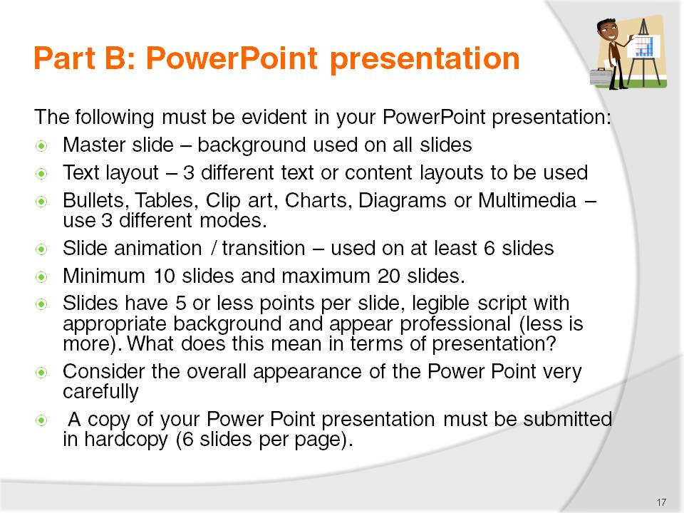
Slide No | Trainer Notes
Show trainees attached sample assessment:
- Set standard of your expectations
- Set due date for part A
- Set due date for part B
- Consider weight of this assessment.

Slide

Slide No | Trainer Notes
 | Sample opening page.

Slide
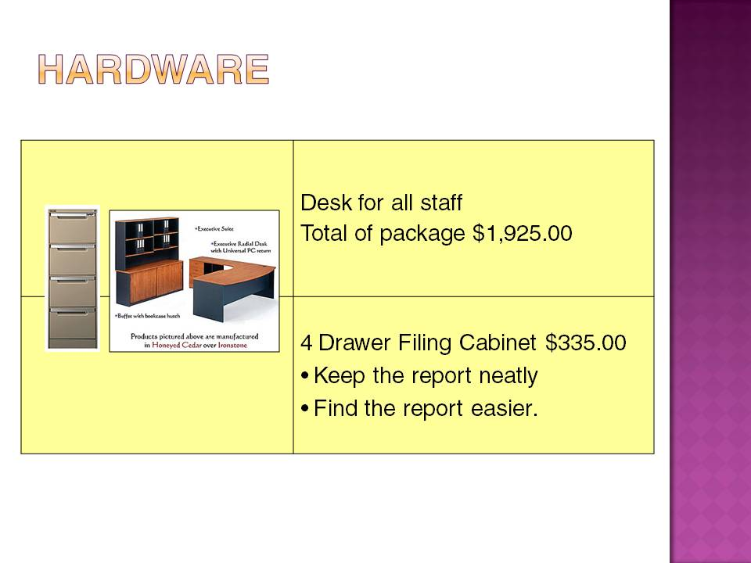
Slide No | Trainer Notes
 | Resources and ideas for project.

Slide
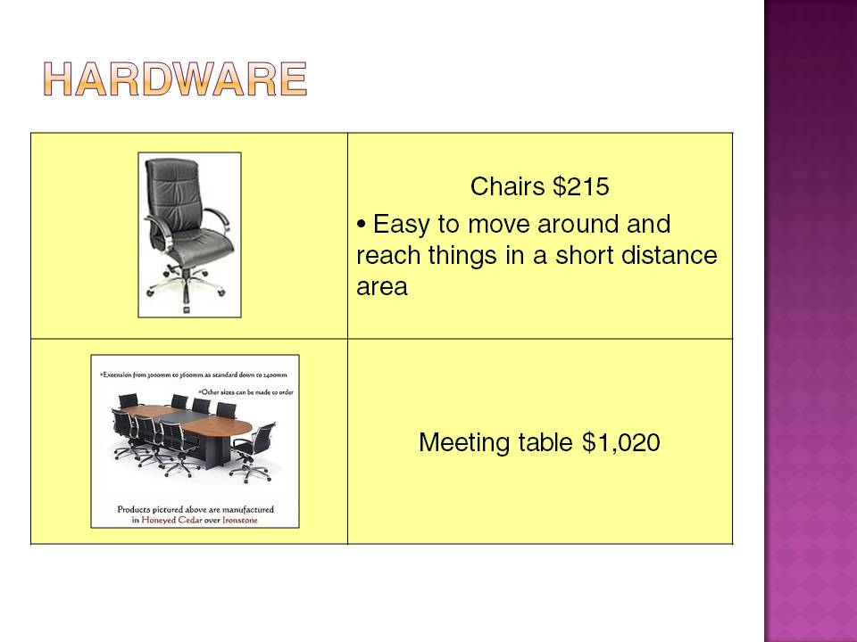
Slide No | Trainer Notes
 | Resources and ideas for project.

Slide
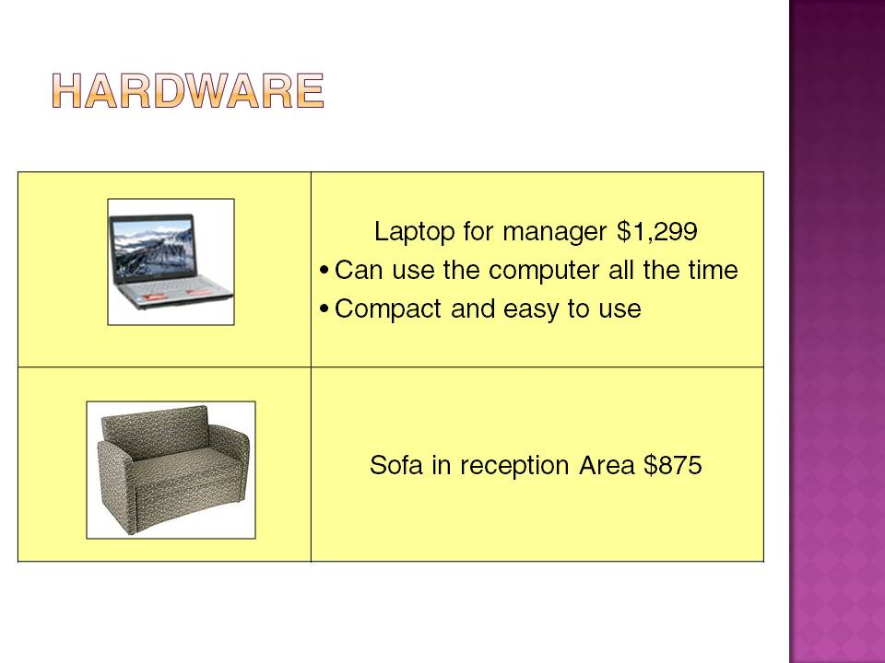
Slide No | Trainer Notes
 | Resources and ideas for project.

Slide
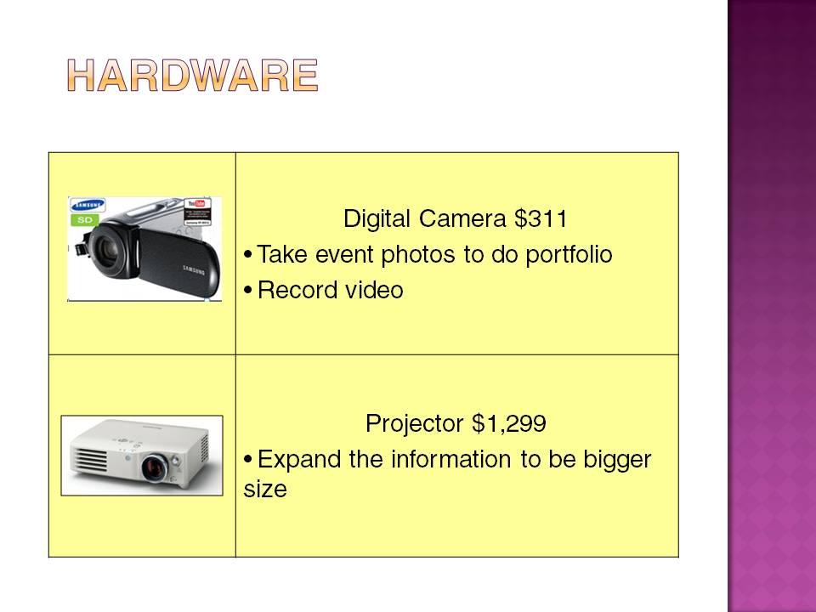
Slide No | Trainer Notes
 | Resources and ideas for project.

Slide
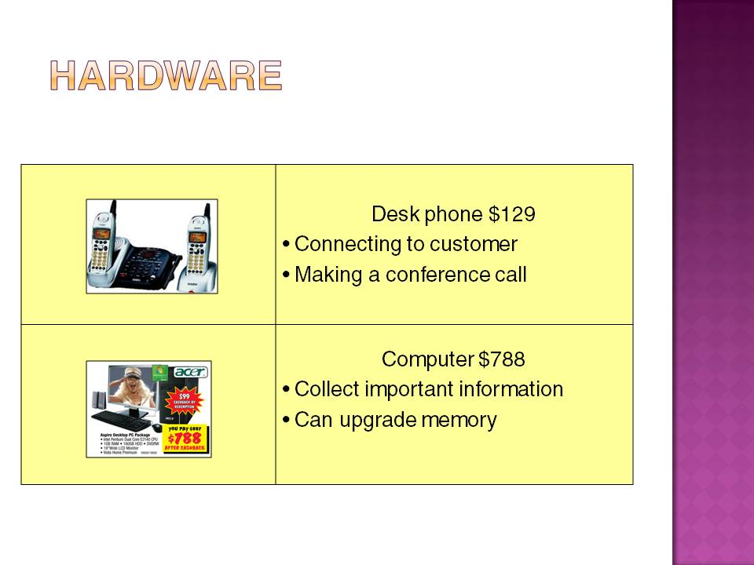
Slide No | Trainer Notes
 | Resources and ideas for project.

Slide
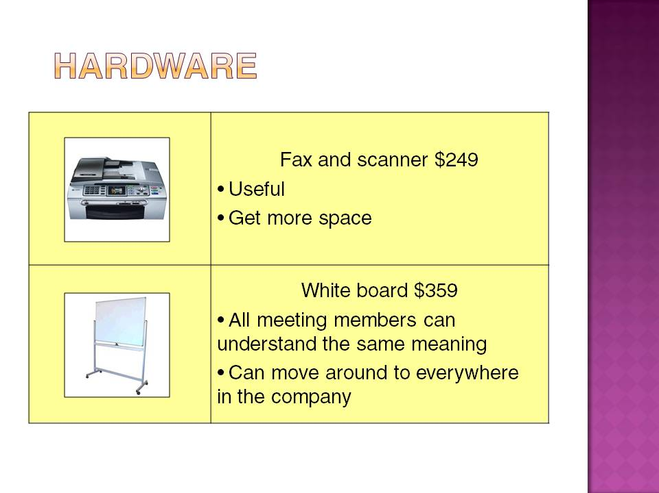
Slide No | Trainer Notes
 | Resources and ideas for project.

Slide
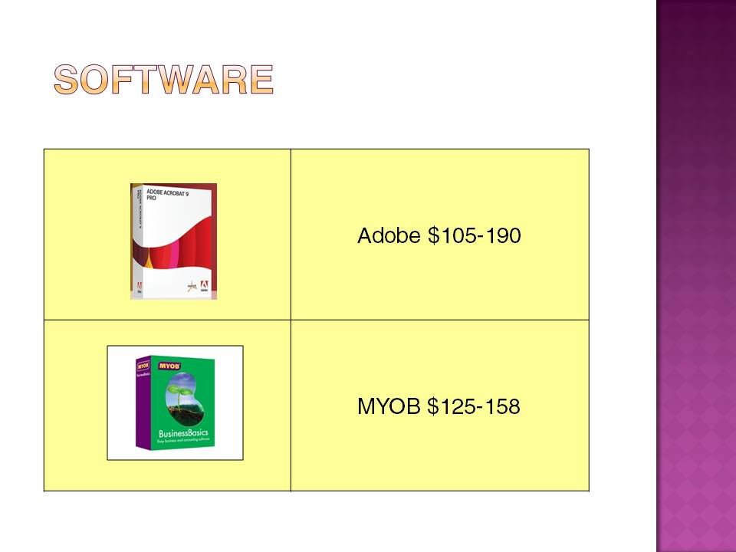
Slide No | Trainer Notes
 | Resources and ideas for project.

Slide
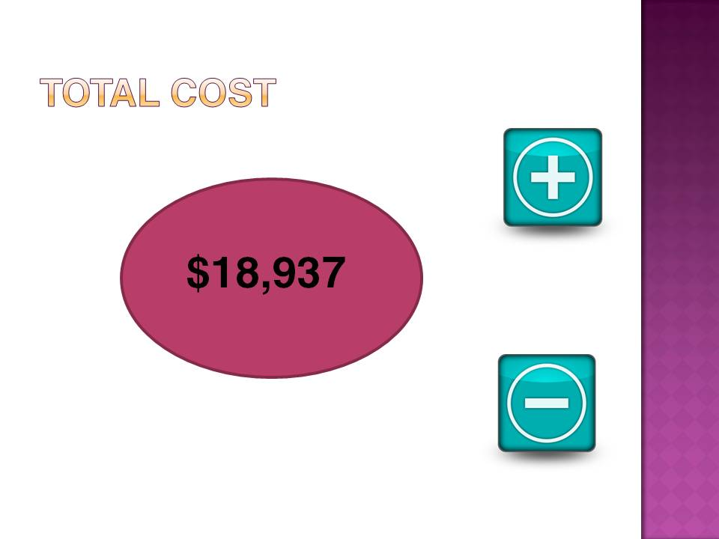
Slide No | Trainer Notes
 | Resources and ideas for project.

Slide
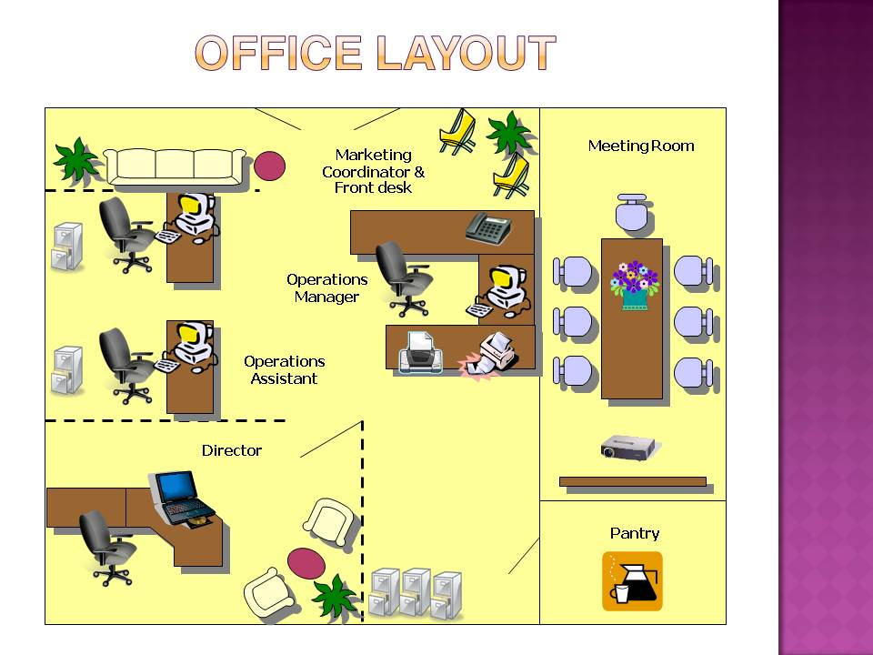
Slide No | Trainer Notes
 | Resources and ideas for project.

Slide
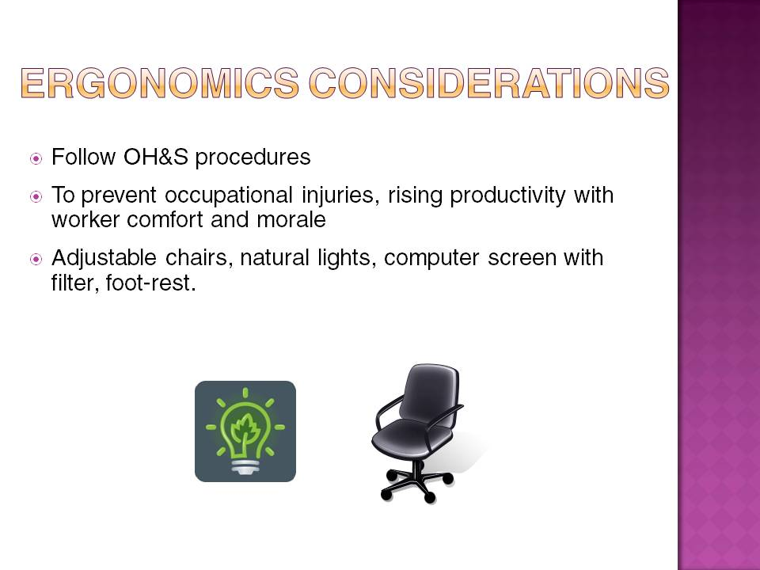
Slide No | Trainer Notes
 | Resources and ideas for project.

Slide
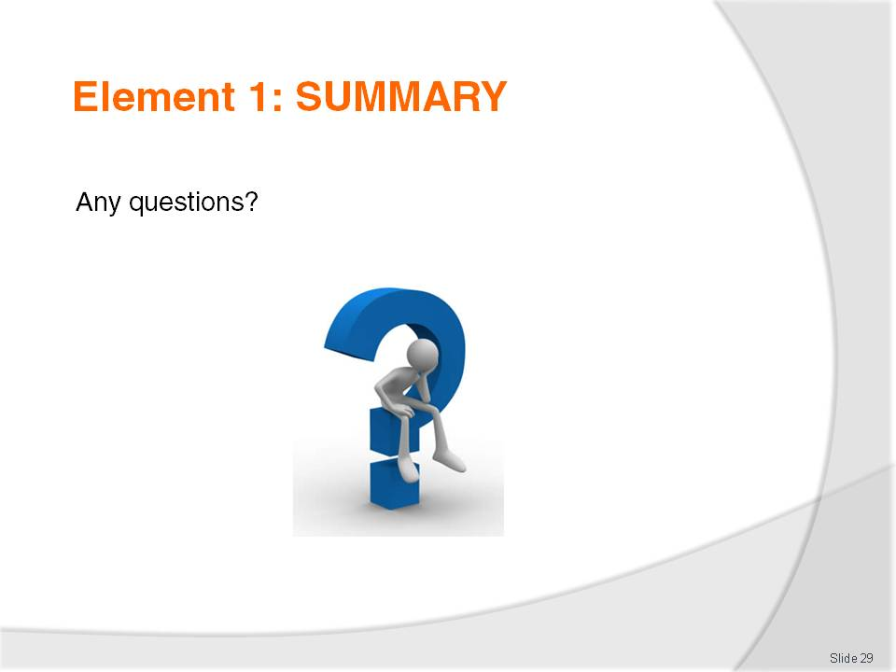
Slide No | Trainer Notes
 | Ensure trainees have no questions about any of the material covered including acronyms used, difference between hardware and software, consumables, etc.

Slide
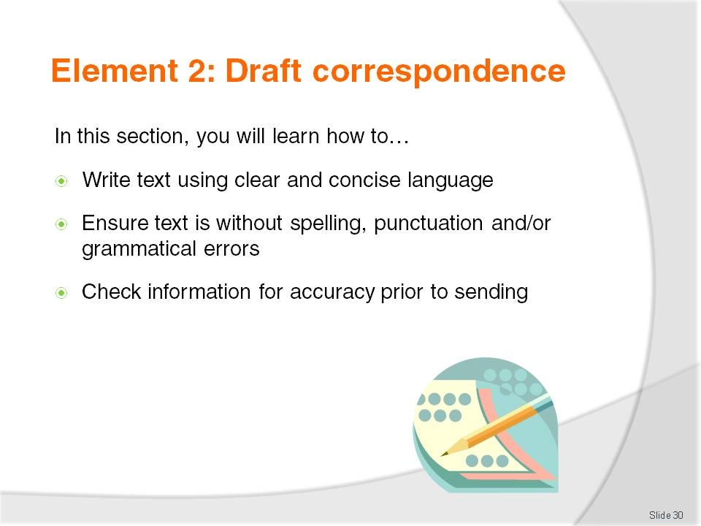
Slide No | Trainer Notes
Start section 2:
- Return marked assessment – Part A
- Ensure trainees are on course with Part B delivery

Slide
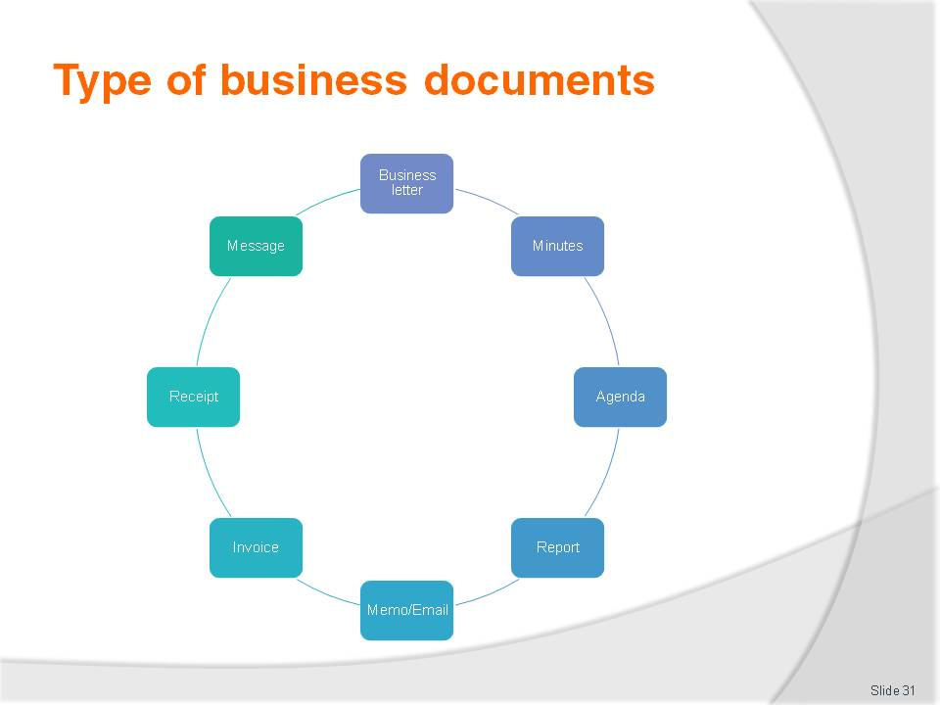
Slide No | Trainer Notes
 | Explain each business document by giving them samples you have brought along to class.

Slide
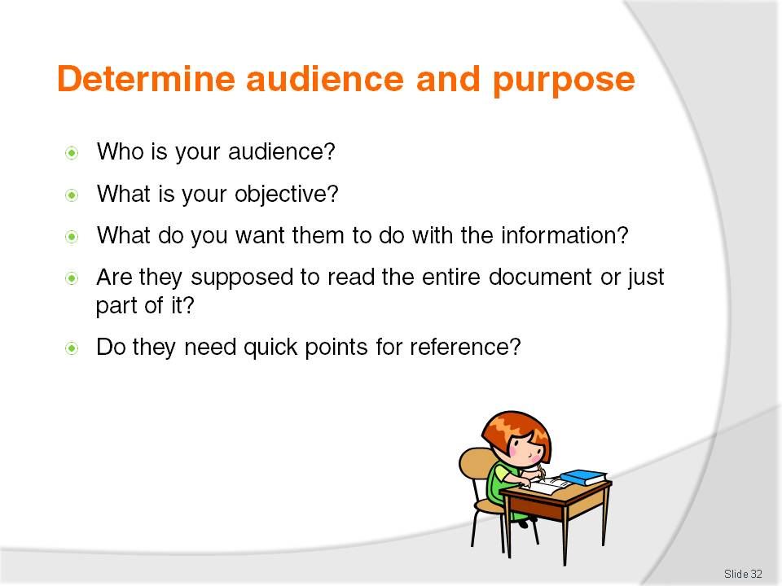
Slide No | Trainer Notes
 | Discuss the above questions as a whole class.

Slide
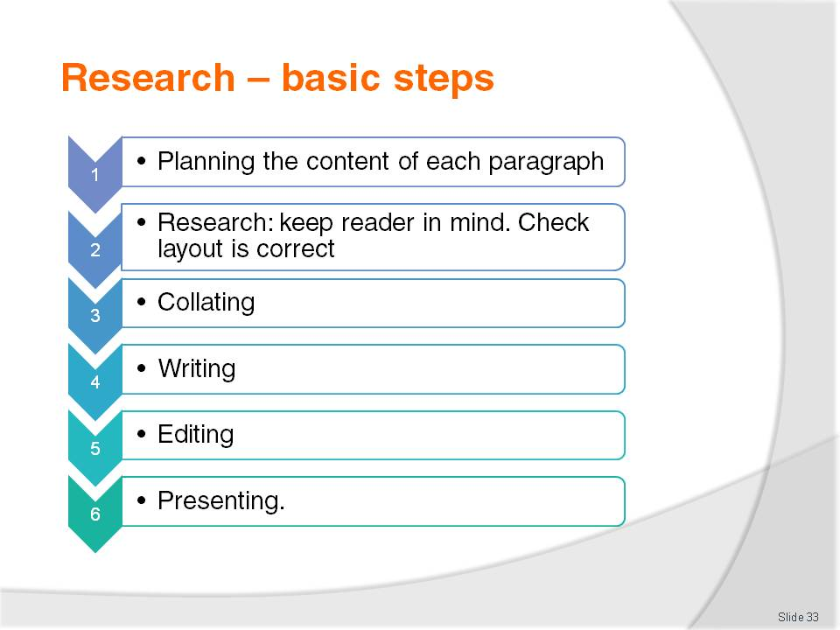
Slide No | Trainer Notes
 | Discuss the basic steps involved in research.

Slide
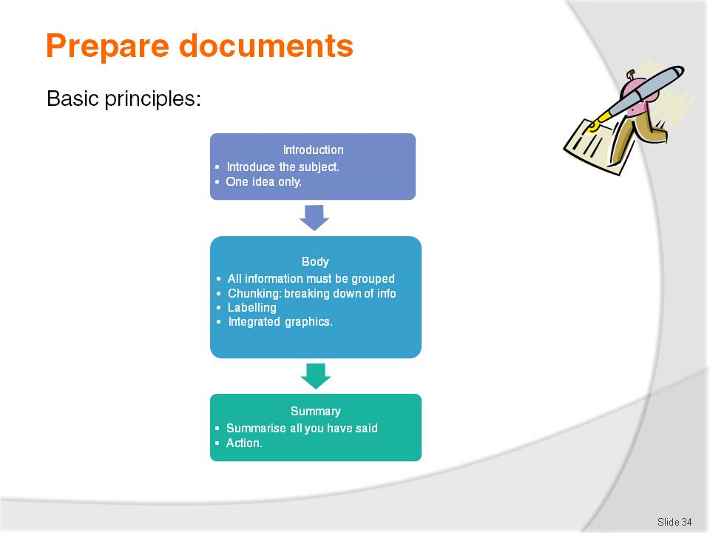
Slide No | Trainer Notes
 | Discuss the basic principles involved in preparing documents.

Slide

Slide No | Trainer Notes
Trainer to go online and show trainees online dictionaries.
Ask trainees to look up the words ‘scope, pax, FIT’ in all dictionaries and in the thesaurus. Which one did they prefer? Why? Suggest to bookmark them as a favourite on their computer for future use.

Slide

Slide No | Trainer Notes
 | Discuss the six steps to good writing.

Slide
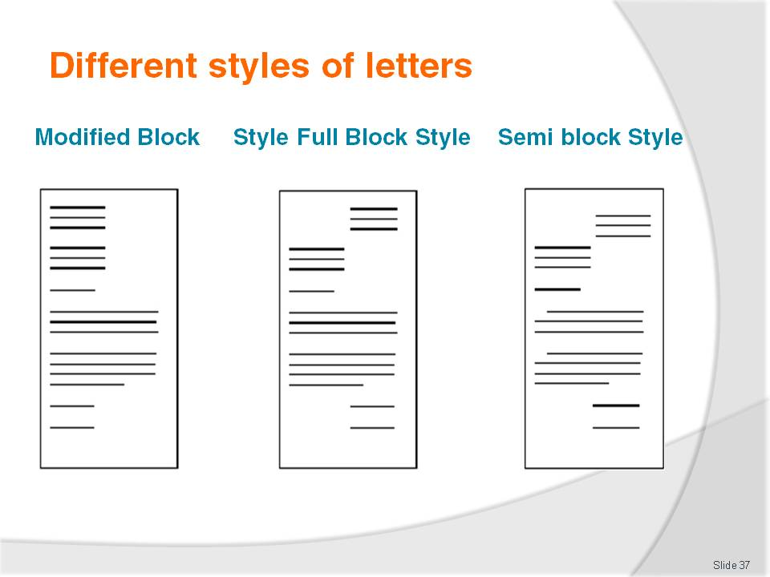
Slide No | Trainer Notes
- Trainer to ask trainees to bring a sample of each different style of letter as above.
- Ask trainees which one is which.
- Trainer to ask trainees to bring in samples and ask them to identify differences.

Slide
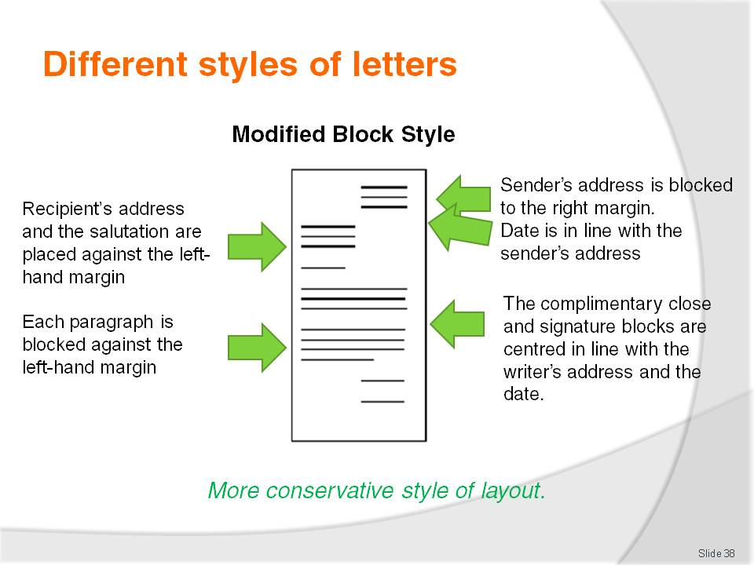
Slide No | Trainer Notes
- Trainer to ask trainees to bring a sample of each different style of letter as above.
- Ask trainees which one is which.
- Trainer to ask trainees to bring in samples and ask them to identify differences.

Slide
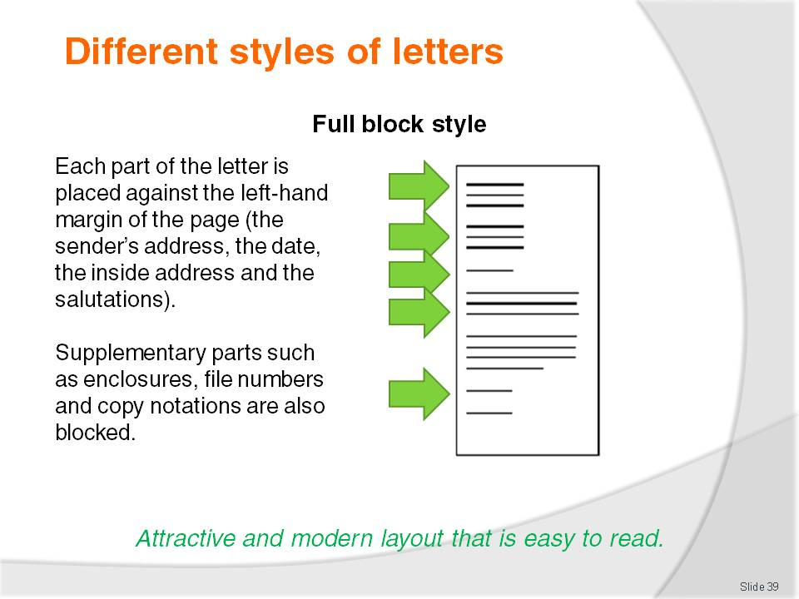
Slide No | Trainer Notes
- Trainer to ask trainees to bring a sample of each different style of letter as above.
- Ask trainees which one is which.
- Trainer to ask trainees to bring in samples and ask them to identify differences.

Slide
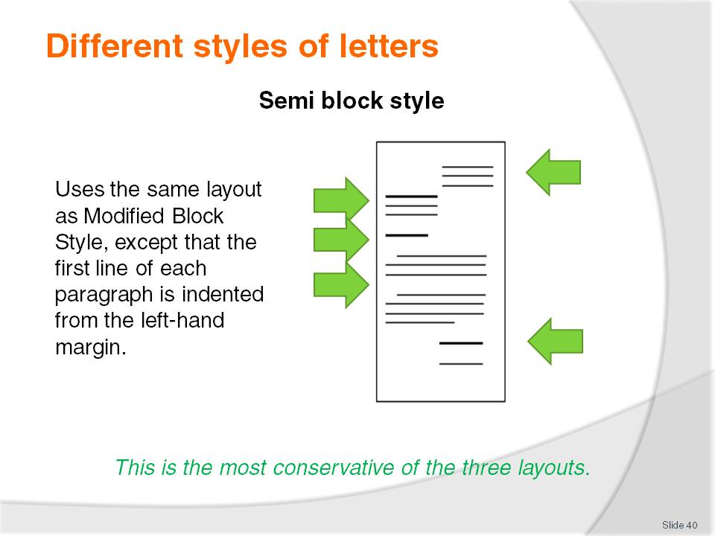
Slide No | Trainer Notes
- Trainer to ask trainees to bring a sample of each different style of letter as above.
- Ask trainees which one is which.
- Trainer to ask trainees to bring in samples and ask them to identify differences.

Slide
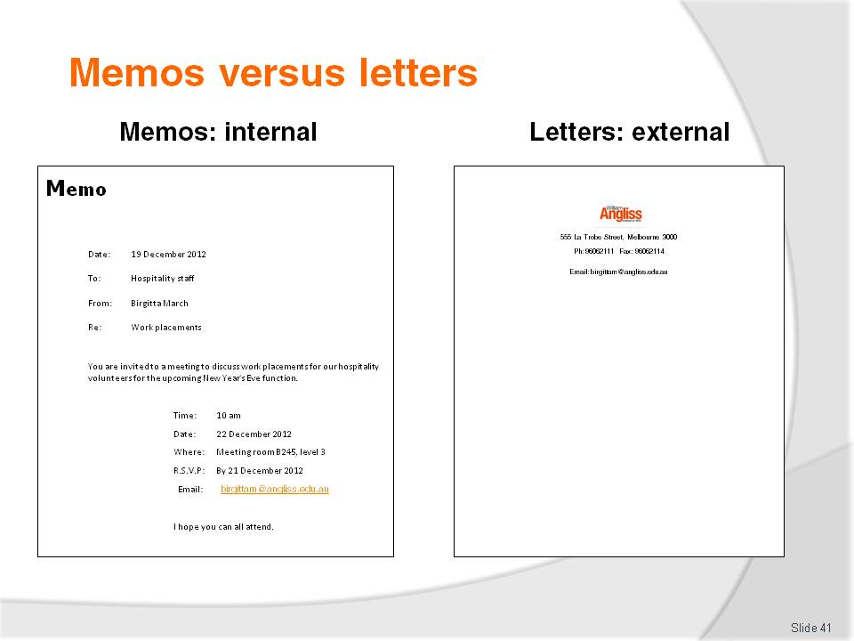
Slide No | Trainer Notes
 | Discuss sample memo in slide.

Slide
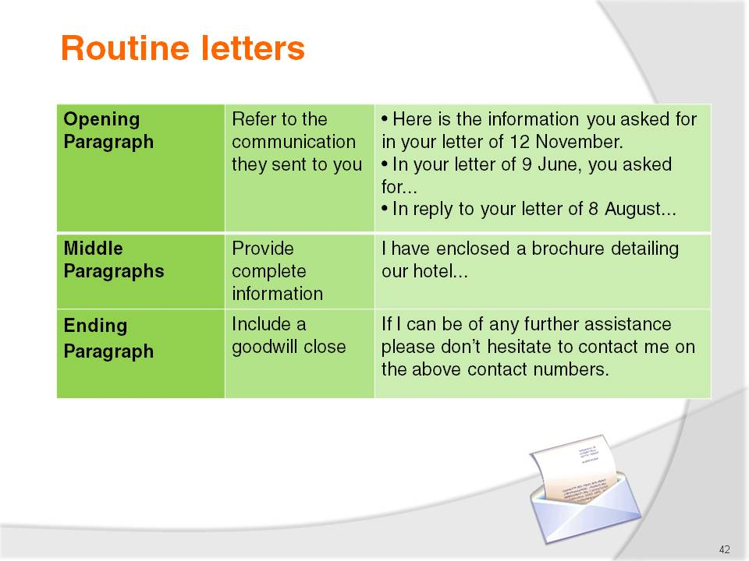
Slide No | Trainer Notes
 | Discuss sample routine letter in slide.

Slide
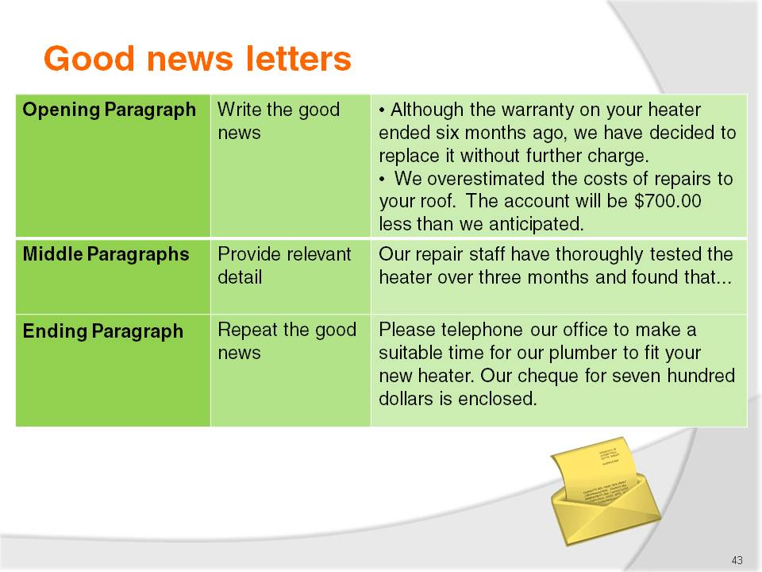
Slide No | Trainer Notes
 | Discuss sample good news letter in slide.

Slide
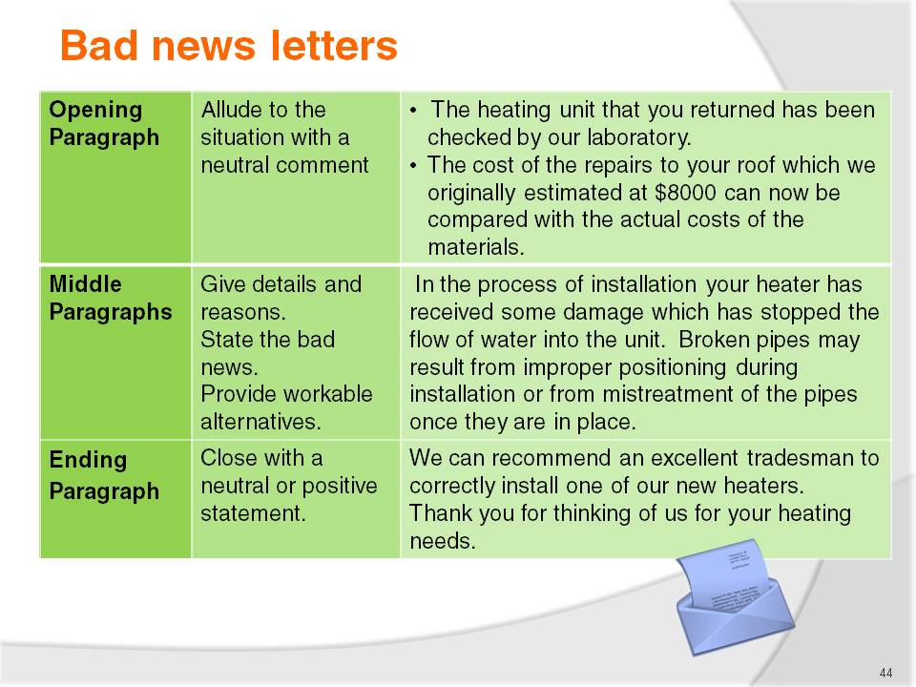
Slide No | Trainer Notes
 | Discuss sample bad news letter in slide.

Slide
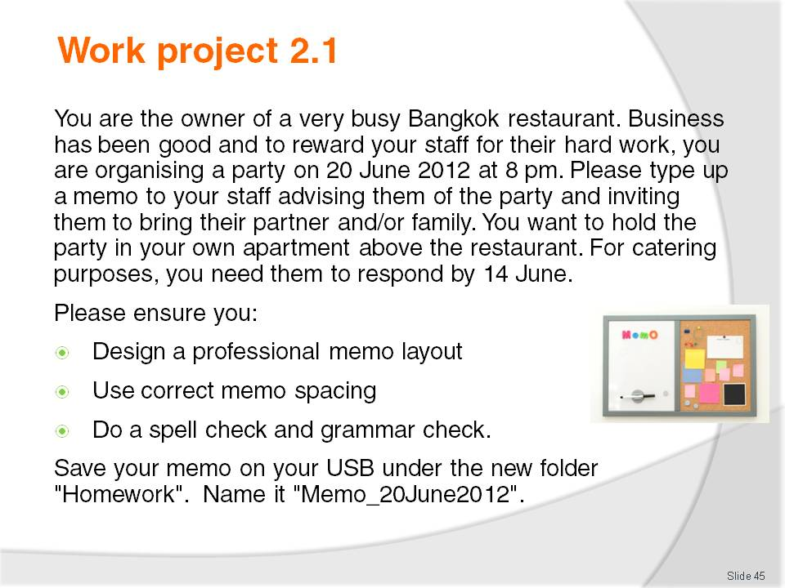
Slide No | Trainer Notes
Trainer is to show trainees how to download a memo template (office button- new-memo template) as the basis of their assessment.
Trainer is then to:
- Read the work project to trainees
- Set a due date for this project to be handed in
- Mark and return the projects to trainees.
This is work project 2 out of 5:
- Remember to assess Part B of previous work project (oral presentation).

Slide
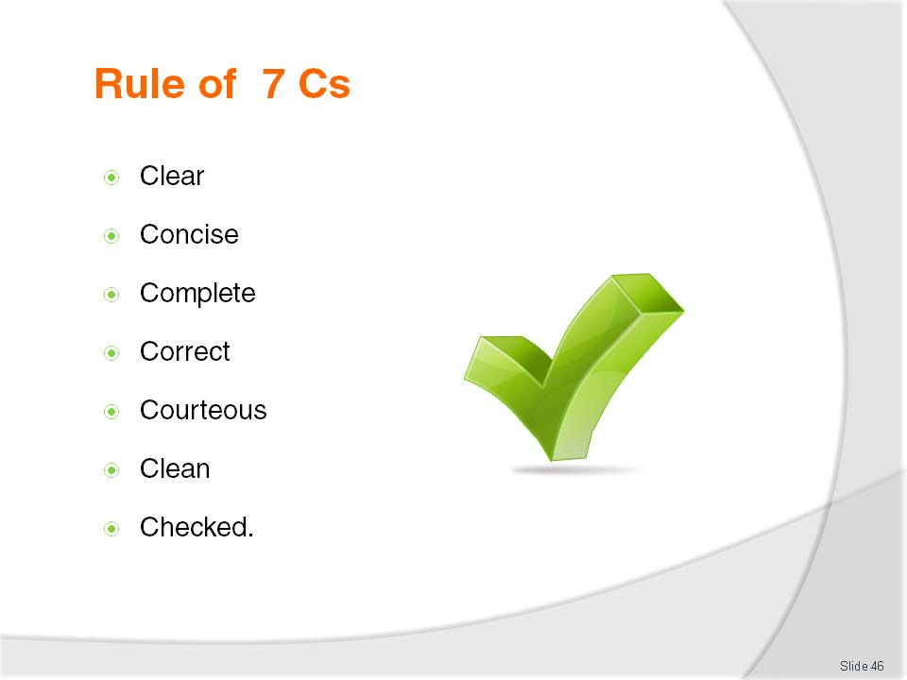
Slide No | Trainer Notes
Rule of 7 Cs:
- Clear - able to be understood in one reading by the recipient (time = money)
- Concise - conveying what has to be stated with a minimum of words, sentences and paragraphs
- Complete - all of the information necessary to understand the correspondence is passed on
- Correct - all of the information conveyed is accurate.
- Courteous - your tone is always polite as you are representing your organization and wish to create goodwill
- Clean - this means that there are no coffee stains, liquid paper, or crossing out on your correspondence. It also means that your work is not cluttered and there is plenty of white space so that the document looks appealing and professional
- Checked - this means your work has been examined for spelling mistakes, grammatical mistakes, format and layout and found to be mistake-free.

Slide
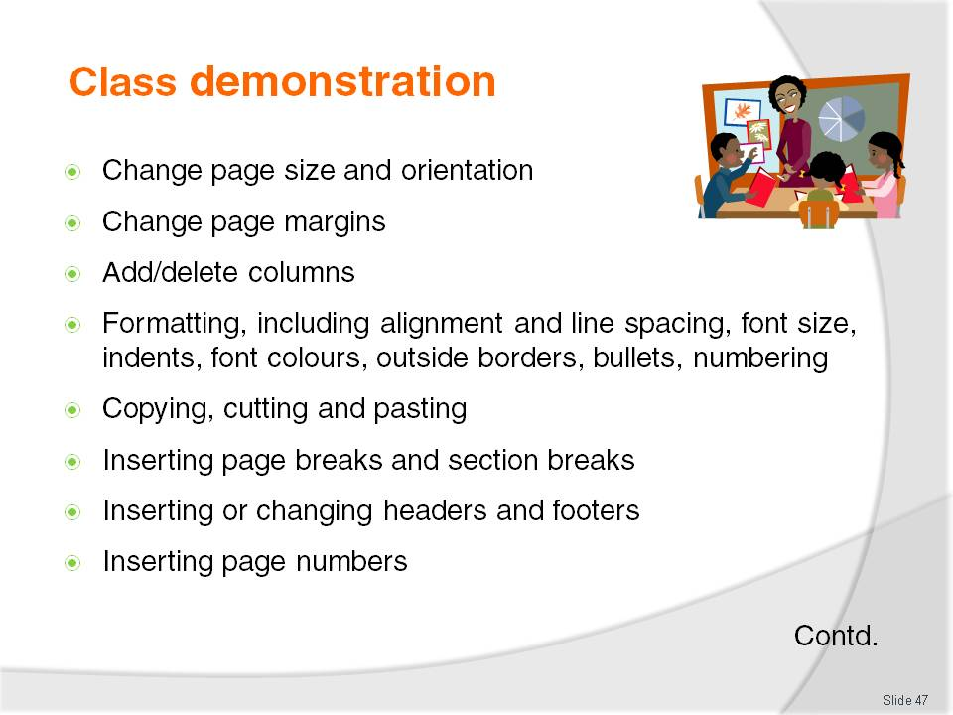
Slide No | Trainer Notes
Trainer is to do a very comprehensive class demonstration showing students how to do the above.
Trainer is to give an exercise to the trainees so they can demonstrate competency.

Slide
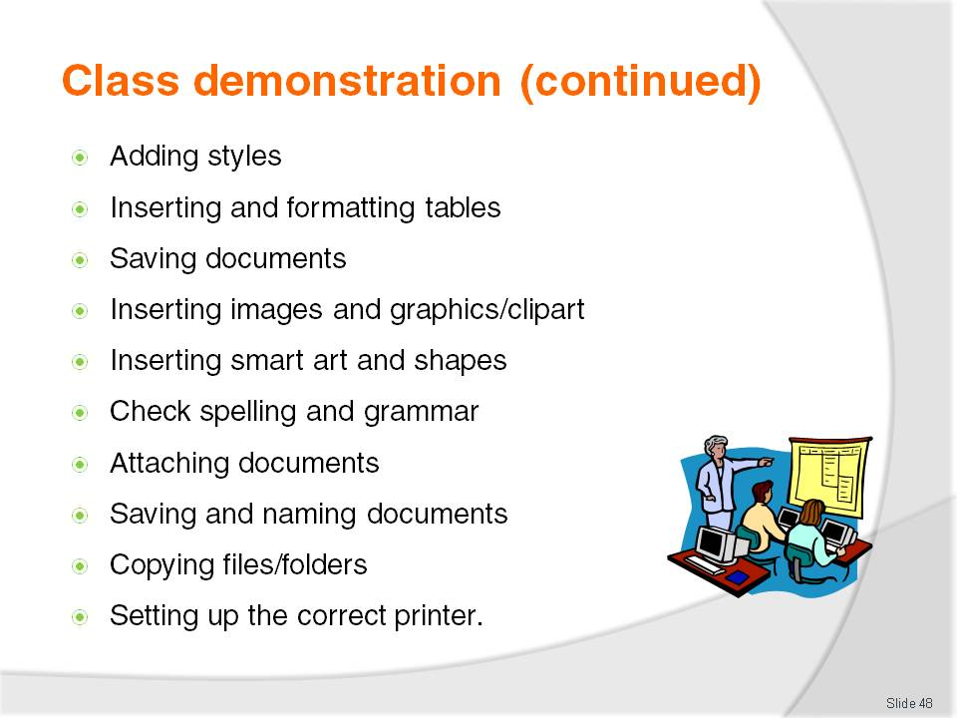
Slide No | Trainer Notes
Trainer is to do a very comprehensive class demonstration showing students how to do the above.
Trainer is to give an exercise to the trainees so they can demonstrate competency.
- Holiday on the Mekong River – see next slides.

Slide
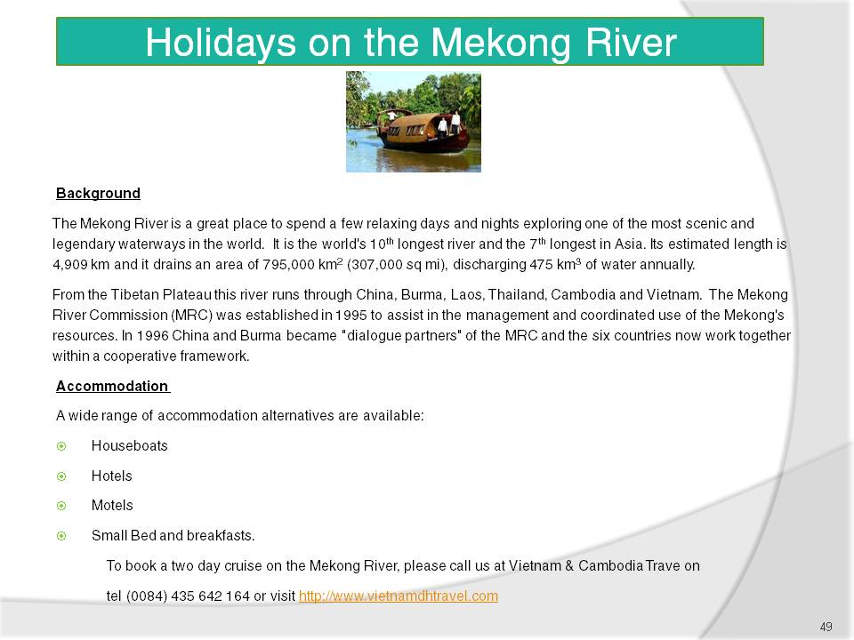
Slide No | Trainer Notes
 | Display this class exercise on the whiteboard/projector. Trainees are to follow instructions on the following page. Trainer can print out copies of this class exercise for easier reference.

Slide
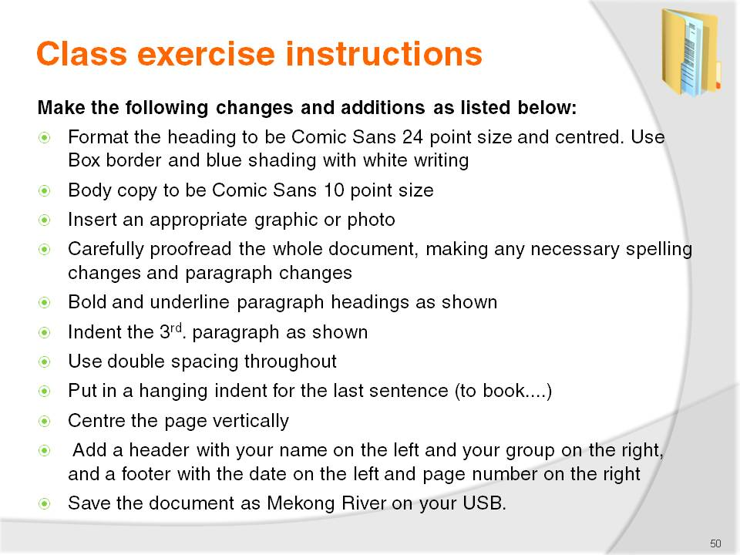
Slide No | Trainer Notes
 | Students to complete the above exercise. Students should do this individually or in pairs depending on the number of computers available.

Slide
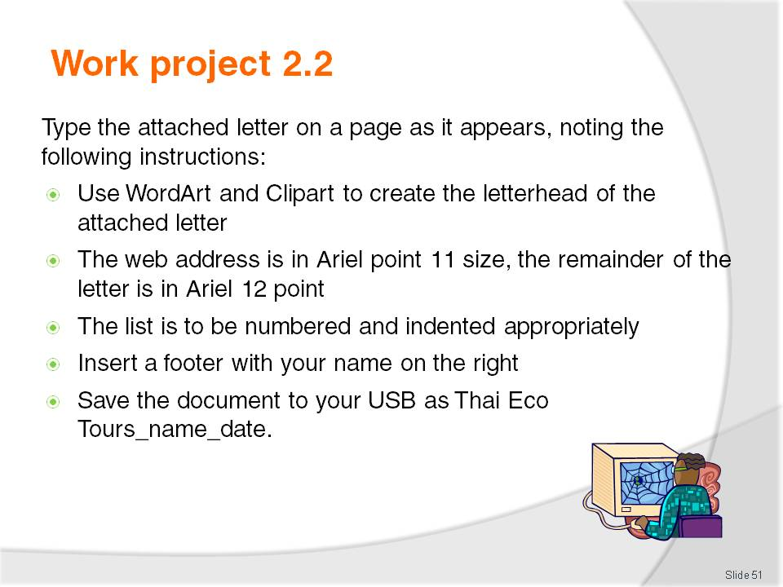
Slide No | Trainer Notes
Trainer is to:
- Read the work project to trainees
- Set a due date for this project to be handed in
- Mark and return the projects to trainees.
This is Workproject 3 out of 5.

Slide

Slide No | Trainer Notes
 | Refer trainees to their manual to see sample.

Slide
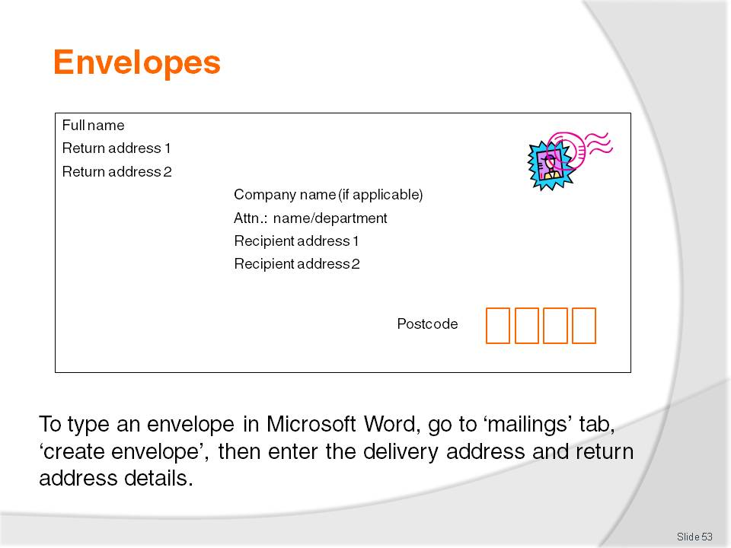
Slide No | Trainer Notes
 | Trainer to demonstrate how to type an envelope in Word.

Slide
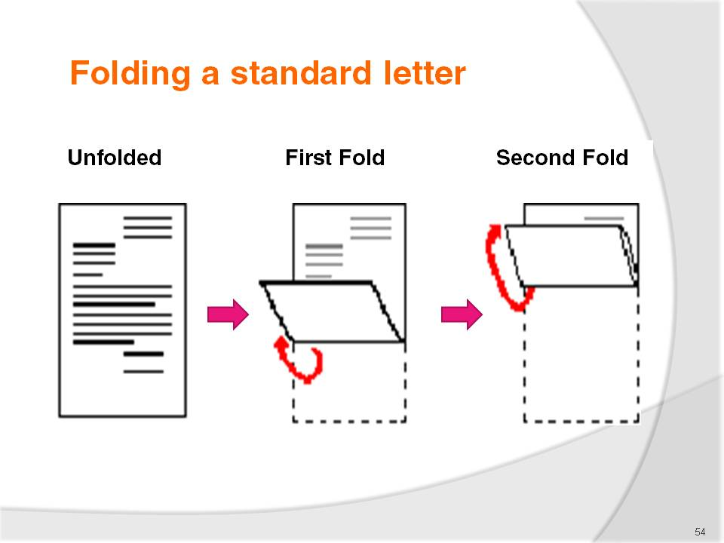
Slide No | Trainer Notes
Show this chart to the trainees. Hand out A4 paper and ask them to fold according to these instructions:
- 1. Begin with the first page of the letter facing towards you
- 2. Crease the letter along a fold one third from the bottom. Fold the letter up to a point one third from the top, covering the writing on the letter
- 3. Make a second horizontal crease one third from the top of the letter where the bottom of the letter had been folded to
- 4. Tuck the bottom into this crease and fold the top over it. The letter will be folded into thirds. It will fit any standard envelope.

Slide
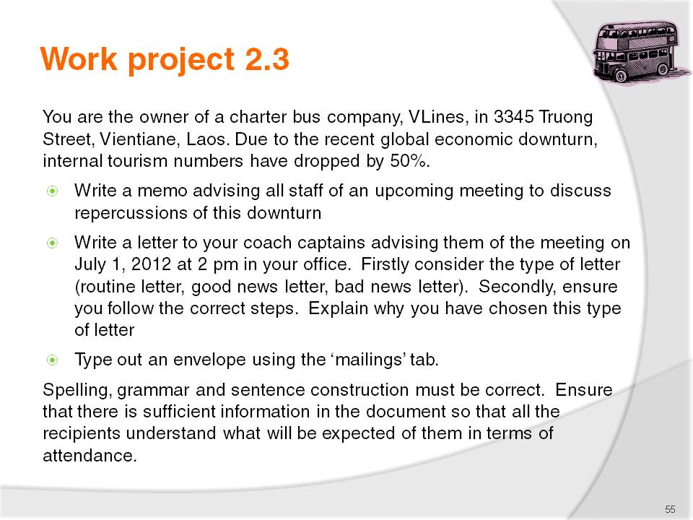
Slide No | Trainer Notes
Trainer is to:
- Read the work project to trainees
- Set a due date for this project to be handed in
- Mark and return the projects to trainees.
This is Workproject 4 out of 5.

Slide
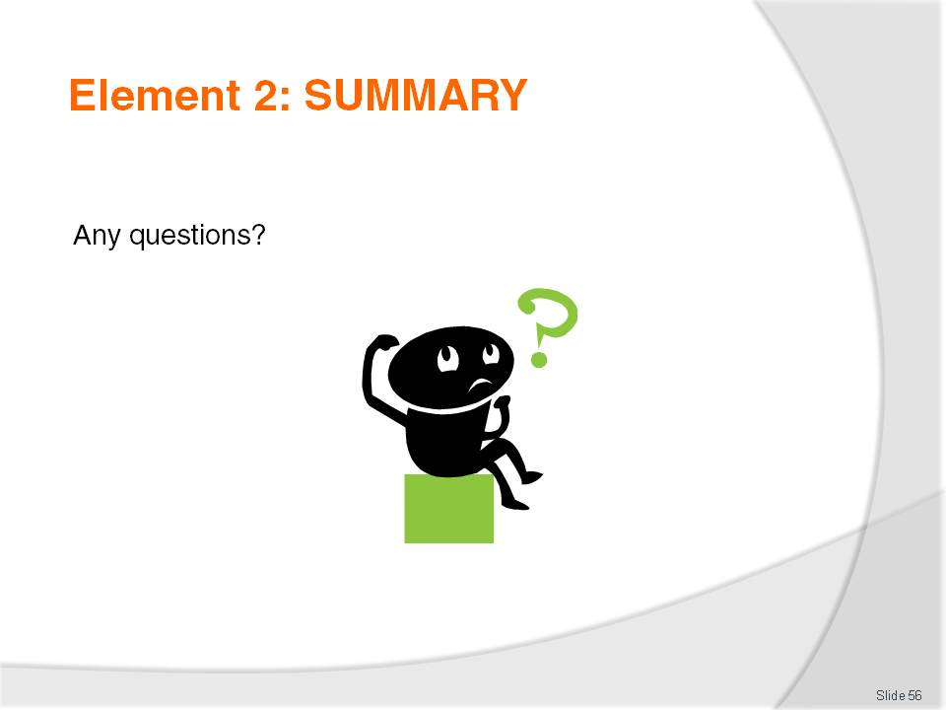
Slide No | Trainer Notes
 | Trainer to revise this element through the summary and provide a general class discussion.

Slide
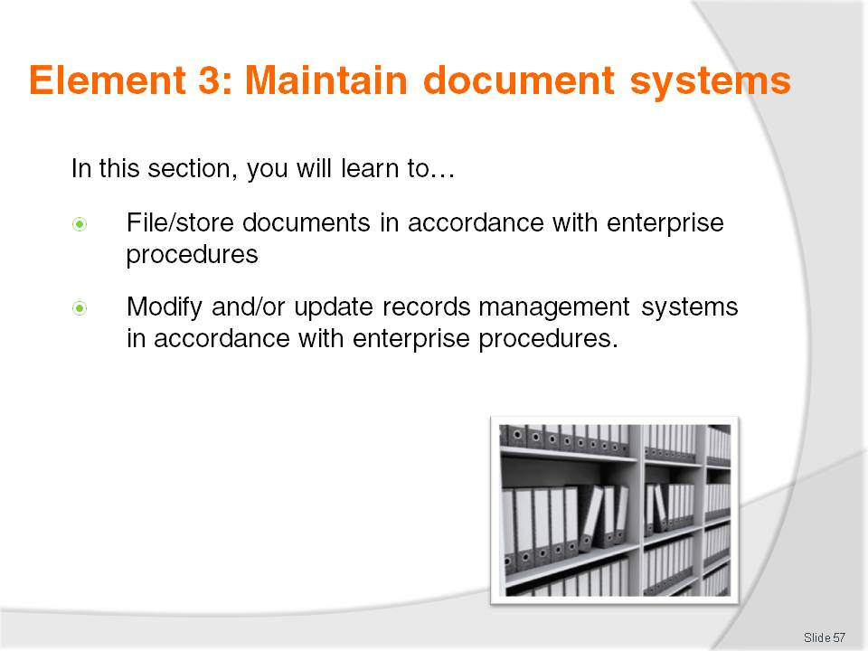
Slide No | Trainer Notes
 | At start of each element, trainer to explain the element in brief.

Slide
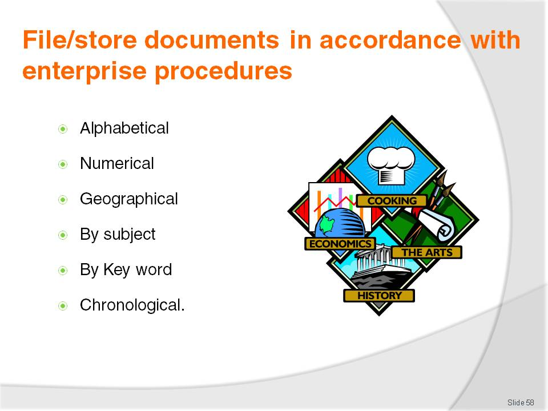
Slide No | Trainer Notes
Trainer to explain his/her own experience when filing according to industry guidelines.
Trainer to ask trainees their experience. “Did anyone ever have trouble finding files? Why?” Or “What did you like about the filing system in use and why?”
Trainer to link the above with the various filing techniques:
Alphabetical
The most commonly used method of filing, the alphabetical system, places files in alphabetical order according to the customer or business name e.g. the telephone book
Numerical
Each file or piece of information is filed in number order, from lowest to highest, according to the number on the document (for example, invoice number) or the customer number
Geographical
Information is indexed alphabetically according to geographical location. States/Provinces are indexed first, followed by the city, town or suburb, then other appropriate information e.g. customer name
Subject
Records are sorted according to the subject matter and filed alphabetically. This allows information on the one topic, or subject, to be easily located.

Key word
A particular word is used as the subject classification and specific descriptors are also allocated to further classify the information. Keyword systems are usually used in large organisations where the keywords are specifically designated.
Chronological
Chronological filing is used in conjunction with other filing methods and involves sorting records according to their date.

Slide
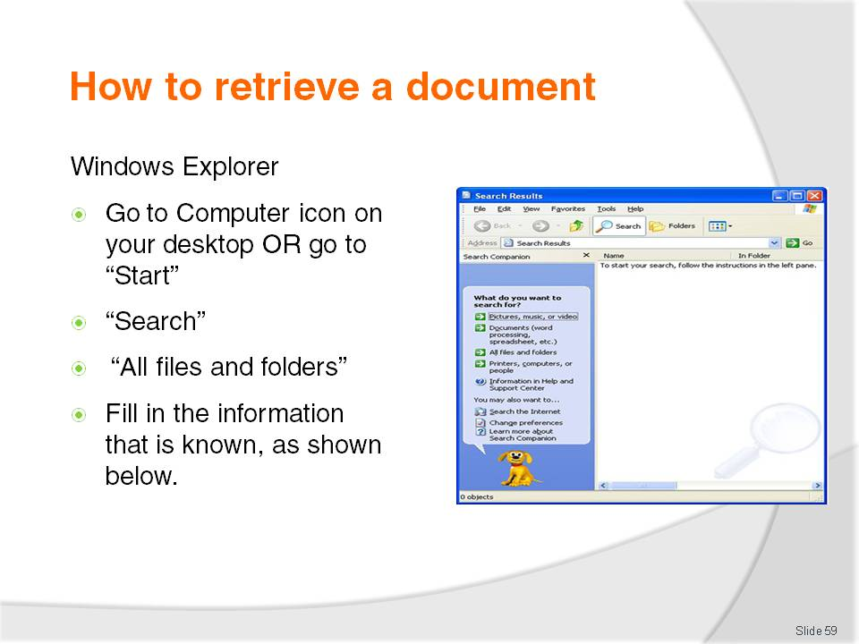
Slide No | Trainer Notes
 | Trainer to do a class demonstration on document retrieval.

Slide
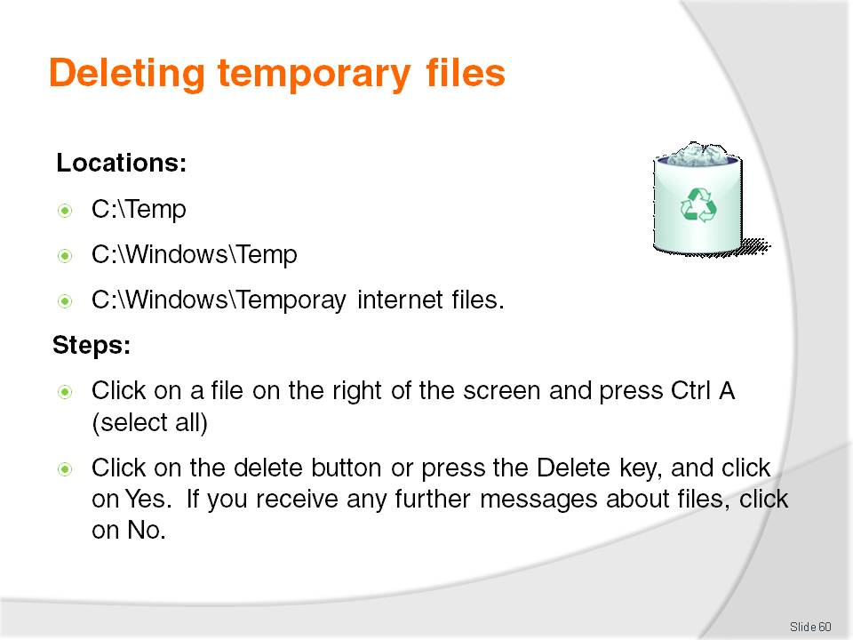
Slide No | Trainer Notes
 | Trainer to do a class demonstration on how to delete all files. Students to do this on their computer.

Slide

Slide No | Trainer Notes
 | Trainer to do a class demonstration on emptying the recycling bin. Students to follow.

Slide
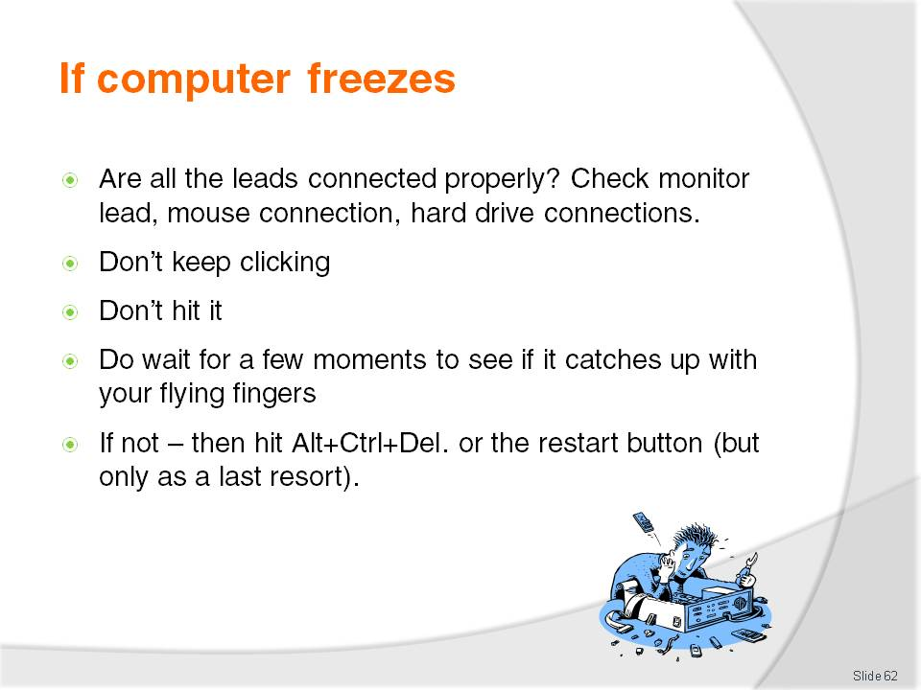
Slide No | Trainer Notes
 | REMIND – trainees to always save everything on a regular basis.

Slide
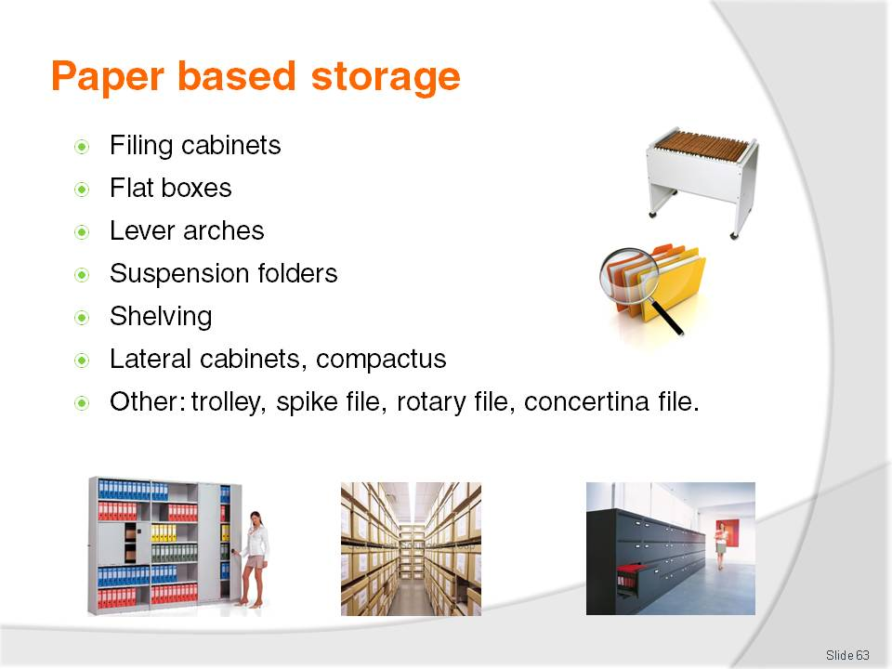
Slide No | Trainer Notes
Trainer to explain own experience with these and advantages/disadvantages he or she experienced.
Ask trainees what they have used to date in the workplace.

Slide
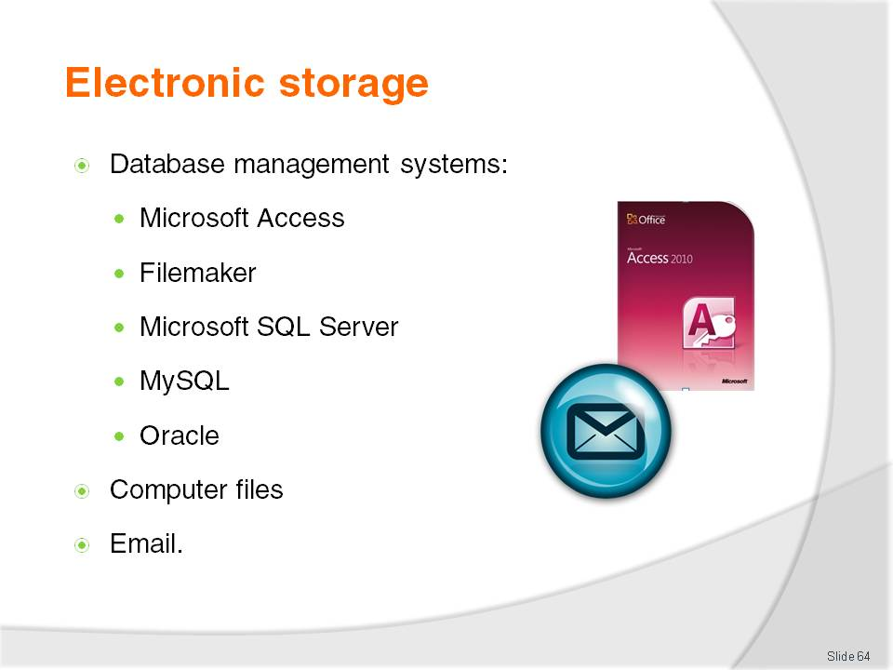
Slide No | Trainer Notes
Trainer to explain own experience with these and advantages/disadvantages he/she experienced.
Ask trainees what they have used to date in the workplace.
Explain that Access has templates for database management. Print-outs of reports.

Slide
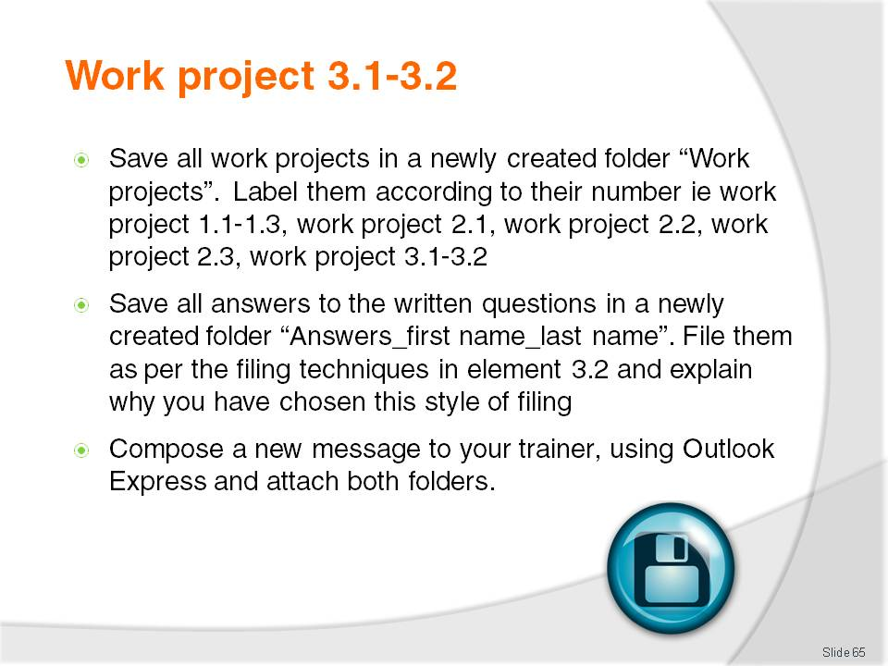
Slide No | Trainer Notes
Trainer is to:
- Read the work project to trainees
- Set a due date for this project to be handed in
- Mark and return the projects to trainees.
This is work project 5 out of 5.

Slide
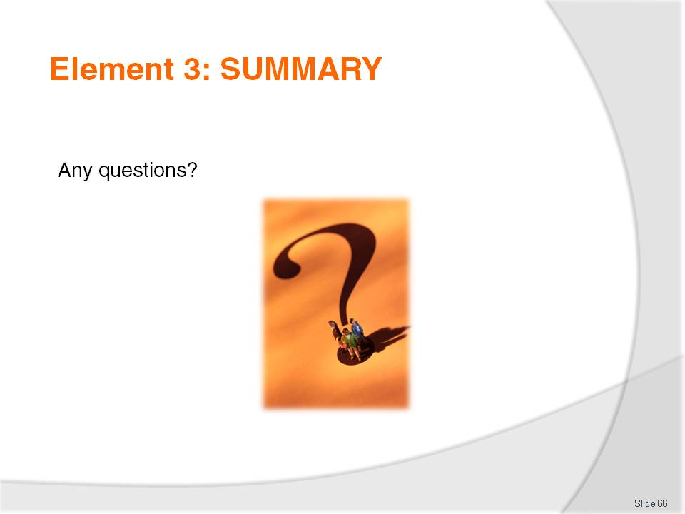
Slide No | Trainer Notes
 | Trainer to revise this element through the summary and provide a general class discussion.

Recommended training equipment
http://www.java2s.com/Tutorial/Microsoft-Office-Word-2007/CatalogMicrosoft-Office-Word-2007.htm

Instructions for Trainers for using
PowerPoint – Presenter View
Connect your laptop or computer to your projector equipment as per manufacturers’ instructions.
In PowerPoint, on the Slide Show menu, click Set Up Show.
Under Multiple monitors, select the Show Presenter View check box.
In the Display slide show on list, click the monitor you want the slide show presentation to appear on.
Source: http://office.microsoft.com
Note:
In Presenter View:
You see your notes and have full control of the presentation
Your trainees only see the slide projected on to the screen
More Information
You can obtain more information on how to use PowerPoint from the Microsoft Online Help Centre, available at: http://office.microsoft.com/training/training.aspx?AssetID=RC011298761033
Note Regarding Currency of URLs
Please note that where references have been made to URLs in these training resources trainers will need to verify that the resource or document referred to is still current on the internet. Trainers should endeavour, where possible, to source similar alternative examples of material where it is found that either the website or the document in question is no longer available online.

Appendix – ASEAN acronyms
AADCP | ASEAN – Australia Development Cooperation Program.
ACCSTP | ASEAN Common Competency Standards for Tourism Professionals.
AEC | ASEAN Economic Community.
AMS | ASEAN Member States.
ASEAN | Association of Southeast Asian Nations.
ASEC | ASEAN Secretariat.
ATM | ASEAN Tourism Ministers.
ATPMC | ASEAN Tourism Professionals Monitoring Committee.
ATPRS | ASEAN Tourism Professional Registration System.
ATFTMD | ASEAN Task Force on Tourism Manpower Development.
CATC | Common ASEAN Tourism Curriculum.
MRA | Mutual Recognition Arrangement.
MTCO | Mekong Tourism Coordinating office.
NTO | National Tourism Organisation.
NTPB | National Tourism Professional Board.
RQFSRS | Regional Qualifications Framework and Skills Recognition System.
TPCB | Tourism Professional Certification Board.







